新人教版五年级英语上册第三单元测试卷
姓名 得分
听力部分
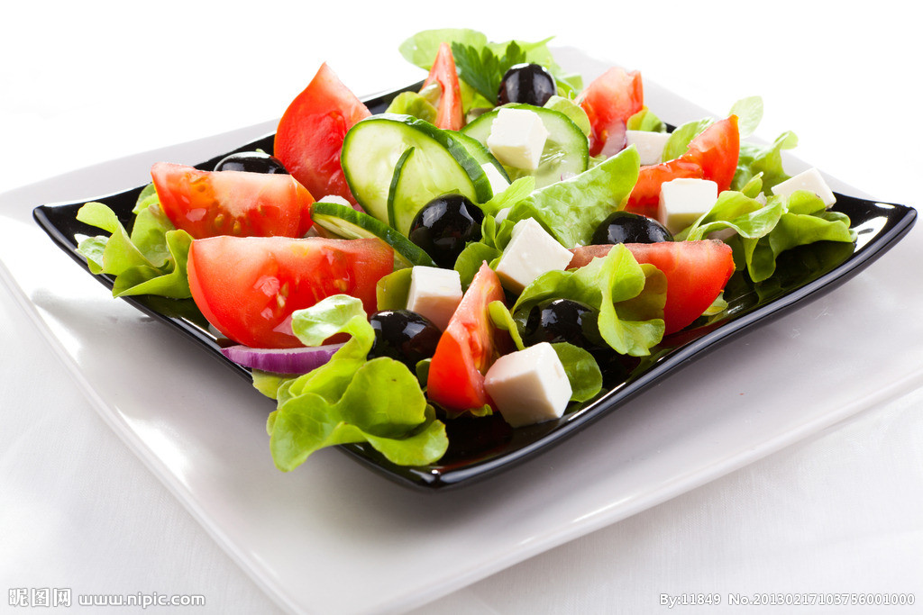
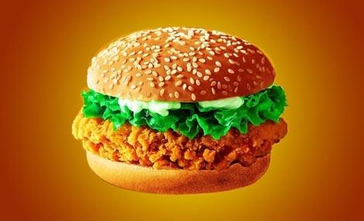
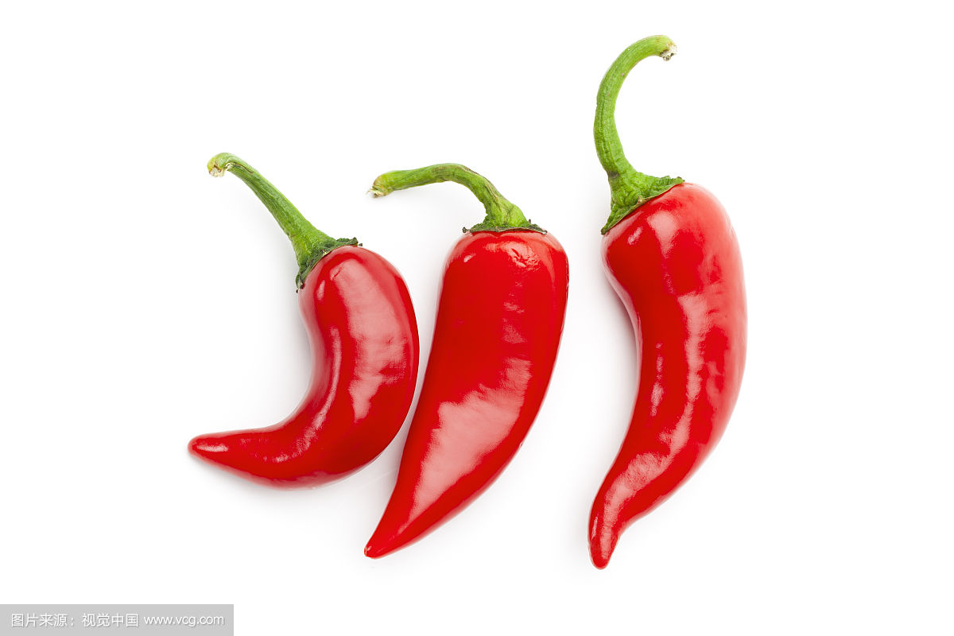
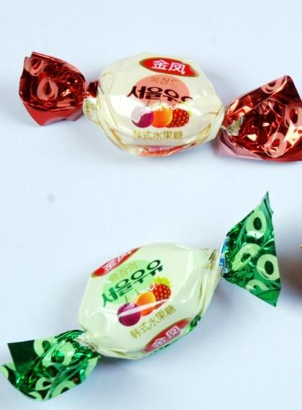

一、听录音，排序号。（10分）

（ ） （ ） （ ） （ ） （ ）
- 听录音，选出你所听到的单词。（10分）
( )1.A.every B.hamburger C often
( )2.A.hot B.what C salad
( )3.A.weekend B.help C.healthy
( )4.A.robot B.read C.ice cream
( )5.A.play sports B.sandwich C.play the pipa
- 听录音，选出你所听到的句子。（10分）
( )1.A.What day is it today?
B.What’s your favorite food?
C.What do you often do on Sundays?
( )2.A.What would you like to eat?
B.What do you have for lunch?
C.What’s your new teacher like?
( )3.A.I like apples.They are sweet.
B.I don’t like grapes. They are sour.
C.I don’t like pears. They are sour.
( )4.A.I have eggs and onions.
B.I’d like some beef noodles.
C.I have eggplant and tomatoes.
( )5.A.That is very good.
B.That sounds good.
C.My favourite food is fish sandwich?
四、听问句，选答句。（10分）
( )1.A.I’d like some beef. B.I have English and math.
C.It’s Thursday.
( )2.A.milk B.beef noodles C.water
( )3.A.Yes, I like. B.I have salads. C.Yes, I do.
( )4.A.milk B.beef noodles C.hot dog
( )5.A.OK. B.I like Friday. C.I often do my homework.

笔试部分
五、找出每组单词中不同类的一个.（10分）
( )1.A.chicken B.beef C.potato
( )2.A.bread B.eat C.noodles
( )3.A.hungry B.fish C.thirsty
( )4.A.sandwich B.milk C.juice
( )5.A.Monday B.Thursday C.weekend
- 单项选择。（10分）
（ ）1.What _______ you like to eat ? I’d like some fish.
A.do B.would C.have
（ ）2.I’d ________ beef.
A.eat B.have C.like
（ ）3.What’s ____ favourite food?----salad
A.for B.you C.your
（ ）4._______ about you ?
A.What B.What is C.What are
（ ）5.What would you like to drink ? --________
A.beef B.sandwich C.tea
七、句子搭配。（10分）
（ ）1.I love vegetables . A.I’d like some tea.
（ ）2.What’s your favourite food? B.Yes,I do.
（ ）3.What would you like to drink ? C.They are healthy
（ ）4.Is ice cream sweet? D.Beef and fish.
（ ）5.Do you like beef ? E.Yes,it is.
八、情景选择（10分）
（ ）1、你想知道别人想吃什么，你会问：
A.What would you like to eat? B.What do you have for lunch?
C.What’s your new teacher like?
（ ）2、他最喜爱的食物是三明治，用英语怎么说？
- Her favourite food is sandwich.
B、His favourite food is sandwich.
C、His favourite food is salad.
（ ）3、你想问别人最喜爱的食物是什么？你会说：
A、What’s your favourite food?
B、What’s your favourite drink?
C、What would you like to drink?
（ ）4、请给我一块三明治，怎么说？
A、I like sandwich. B、A sandwich，please.
C、I’d like a sandwich.
（ ）5、我想要一些牛奶，怎么说？
A、I love some milk. B、I’d like some tea.
C、I’d like some milk.
- 连词成句。(10分)
- some， like， beef， I’d （.）

- favourite, My, chicken, is, food(.)

- beef noodles,have,and,today,fish sandwiches,We(.)

- would, What, like,, you, eat, to (?)

- your,What’s,food, favourite(?)

- 阅读理解。（10分）
Look, this is Jack, my new friend. He is an English boy. He has short black hair and big eyes. He’s tall and strong. He has a new blue schoolbag. His favourite food is chicken. He has a happy family. There are four people in his family. His father is a doctor. His mother is a doctor, too. He has a baby brother. His brother is only three. He is very lovely. They all like China.
( ) 1.My new friend is ________________.
A. Zhang Peng B. Jack C. Mike
( ) 2. Jack’s brother is ________________.
A. three B. thirteen C. two
( ) 3.Jack has a(an) ________________schoolbag.
A. orange B. white C. blue
( ) 4.Jack’s mother is a ________________.
A. doctor B. teacher C. player
( ) 5.Jack’s favourite food is________________.
- fish B. beef C. chicken
听力材料
一、听录音，排序号。（10分）
1、hot
2、hamburger
3、sweet
4、salad
5、ice cream
二、听录音，选出你所听到的单词。（10分）
- hamburger
- salad
- sealthy
- robot
- sandwich
三、听录音，选出你所听到的句子。（10分）
1.What’s your favorite food?
2.What would you like to eat?
3.I like apples.They are sweet.
4.I’d like some beef noodles.
5.My favourite food is fish sandwich?
四、听问句，选答句。（10分）
1、What would you like to eat?
2、What’s your favorite food?
3、Do you like ice cream？
4、What’s your favorite drink?
5、What do you often do on the weekend？

