PEP小学六年级上学期英语期中精品试题
听力部分
- 听音，选出你听到的单词。（6'）
（ ）1、 A.bike B.bookstore C.bus D.buy
（ ）2、 A.come B.cinema C. company D.comic
（ ）3、 A.how B.hospital C.hobby D.help
（ ）4、 A.mother B.morning C.magazine D.meet
（ ）5、 A.please B.policeman C.post office D.plane
（ ）6、 A.tonight B.traffic C.turn D.then
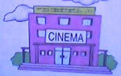
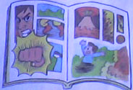
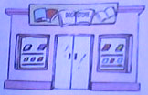
- 听音，标号。（12'）

( )

( )

( )

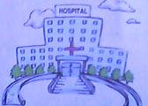
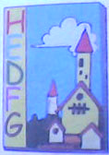
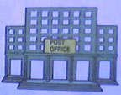

( ) ( ） （ ）
三、听音，根据听到的内容选择正确的答案。（10'）
（ ）1、A. school B. This morning C. By train
（ ）2、A. Sometimes I go by plane. B.You can go by the No.20bus. C. It's next to the post office.
（ ）3、A.I'm going to buy a story book. B.You're welcome.
C.It's east of the cinema.
（ ）4、A.At 12:00 B.It's near the bookstore.
C.It's next to the hospital.
（ ）5、A. Tonight. B. It's next to the post office.
C. Wait at the yellow light.
- 听音，补充对话中缺少的单词（13’）。
- A： do you go to school ? B:Usually I go by bike.
- A:Can I go ? B:Sure.
- A:What are you going to do ?
B:I'm going to visit my grandparents.
- A:How do we the bookstore ?
B:We can go by bike.
- A: is the hospital ? B：It's next to the bookstore .
Turn at the ,then . It's on the .
笔试部分
- 看图写单词。（10'）
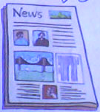
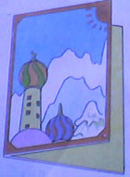
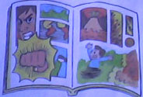
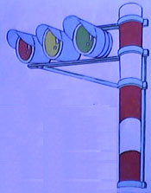

- 选择填空。（12'）
（ ）1、You must at a red light.
A. go B. wait C. stop
（ ）2、What are you to do tonight ?
A. go B. goes C.going
（ ）3、How can we the bookstore ?
A.near B.get to C. next to
（ ）4、When _____ you going ？
- am B. is C. are
（ ）5、He his grandparents next Sunday.
A.visit B. is going to visit C. are going to visit
（ ）6、 ，is there a bookstore near here ?
A. Hello B. Hi C. Excuse me
- 连词成句。（12'）
- bike Usually go I the park by to ( .)

- bus can go the by You No.16 ( . )

- hospital next It's the to ( . )

- cinema left the Turn at ( . )

- going What you to are buy ( ? )

- this Where going you are evening ( ? )

- 从B栏选出A栏的正确答案。（10'）
A B
( )1、What are you going to buy ? A. Turn left at the cinema. It's on the right.
( )2、How can I get to the Shang Yue Park? B.Usually I go to park by bike.
( )3、How do you go to park? C.I'm going to the bookstore.
( )4、Where is the school,pleace? D.I'm going to buy a story--book.
( )5、Where are you going this evening ? E.You can go by the No.62bus.
- 阅读短文，判断正误。（10'）
Zhang : What are you going to do this afternoon ?
John : I'm going to visit my grandparents.
Zhang : How do you get there?
John : I get there by bus.
Zhang : Where do they live ?
John : Their home is near the Science Museum. I turn right at the traffic lights in front of the subway station, then go straight. Their home is on the right .
Zhang : I'm going to the Science Museum this afternoon.
John : Let's go together after lunch .
( 1 )Zhang Peng is going to visit his grandparents. ( )
( 2 )Zhang Peng is going to the Science Museum this afternoon.( )
( 3 )John's grandparents live next to the Science bookstore. ( )
( 4 )Zhang Peng and John are going after lunch. ( )
( 5 )John is going to his grandparent's home by bike . ( )
- 作文。（5'）
这个周末，你打算干些什么呢？请你用英语写下来。
要求：1、用be going to句式写话。
2、不少于5句。

