Unit 4测试卷
听力部分（30分）
一、听录音，给下列图片排序。（5分）






( ) ( ) ( ) ( ) ( )
二、听录音，选择你所听到的句子。(5分)
( ) 1. A. Do you want to cook? B. Do you like food?
( ) 2. A. The cat loves sleep. B. The cat just sleeps.
( ) 3. A. I like drawing cartoons. B. I like playing sports.
( ) 4. A. John likes flying kites and singing English songs.
B. John likes listening to music and watching TV.
( ) 5. A. I don’t have any cake. B. I want to eat some cake.
三、听录音，选择正确的答语。(10分)
( ) 1. A. I like drawing pictures. B. She likes swimming.
C. Mike likes playing basketball.
( ) 2. A. Yes, I do. B. No, he isn’t. C. Yes, he does.
( ) 3. A. Great! B. Yes, we do. C. No, we don’t.
( ) 4. A. Yes, he lives in Tianjin.
B. No, she watches cartoons on TV.
C. Yes, he goes to work by bus.
( ) 5. A. He likes drawing. B. He likes reading books.
C. She likes listening to music.
四、听录音，判断下列句子的正(T)误(F)。(10分)
( ) 1. Sam is from Australia.
( ) 2. Sam’s father likes playing football.
( ) 3. Sam’s mother can make Chinese food.
( ) 4. Sam’s mother likes playing the pipa.
( ) 5. Sam’s family like China very much.
笔试部分（70分）
五、选出不同类的单词。（5分）
( ) 1. A. live B. love C. club
( ) 2. A. cook B. make C. bike
( ) 3. A. has B. his C. does
( ) 4. A. shall B. join C. play
( ) 5. A. different B. interesting C. thing
六、单项选择。 (10分)
( ) 1. Usually my mother ______ the dishes after dinner.
A. do B. doing C. does
( ) 2. I want ______ to the supermarket with my sister this afternoon.
A. go B. to go C. going
( ) 3. How many ______ do you have?
A. hobby B. hobbys C. hobbies
( ) 4. Let’s _______ Chinese together.
A. study B. studying C. studies
( ) 5. I’m writing _____ email to my new pen pal.
A. a B. an C. the
七、读一读，选一选正确的答语。(10分)
( ) 1. What’s your hobby? A. They are talking about their new teacher.
( ) 2. What’s her mother’s hobby? B. She likes listening to music.
( ) 3. How old is your pen pal? C. She is fourteen years old.
( ) 4. What are they talking about? D. I like reading stories.
( ) 5. Does he live in Hainan? E. Yes, he does.
八、根据汉语意思完成句子。(10分)
1. 你哥哥的业余爱好是什么？
_______ _______ your brother’s hobby?
2. 我喜欢唱歌跳舞。
I like _______ and _______.
3. 吉姆，你正在做什么？
What ______ you _______, Jim?
4. 我对美术很感兴趣。
I am very _______ _______ art.
5. 小猫喜欢睡觉。
The cat loves _______ _______.
九、Amy 在向同学们介绍自己的笔友，你能根据对话内容，选出哪位是Amy的笔友吗？ (5分)
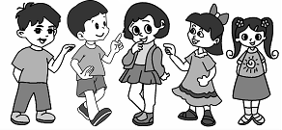

—Is he a boy?
—Yes, he is.
—Does he like listening to music?
—No, he doesn’t.
—Does he like drawing pictures?
—Yes, he does.
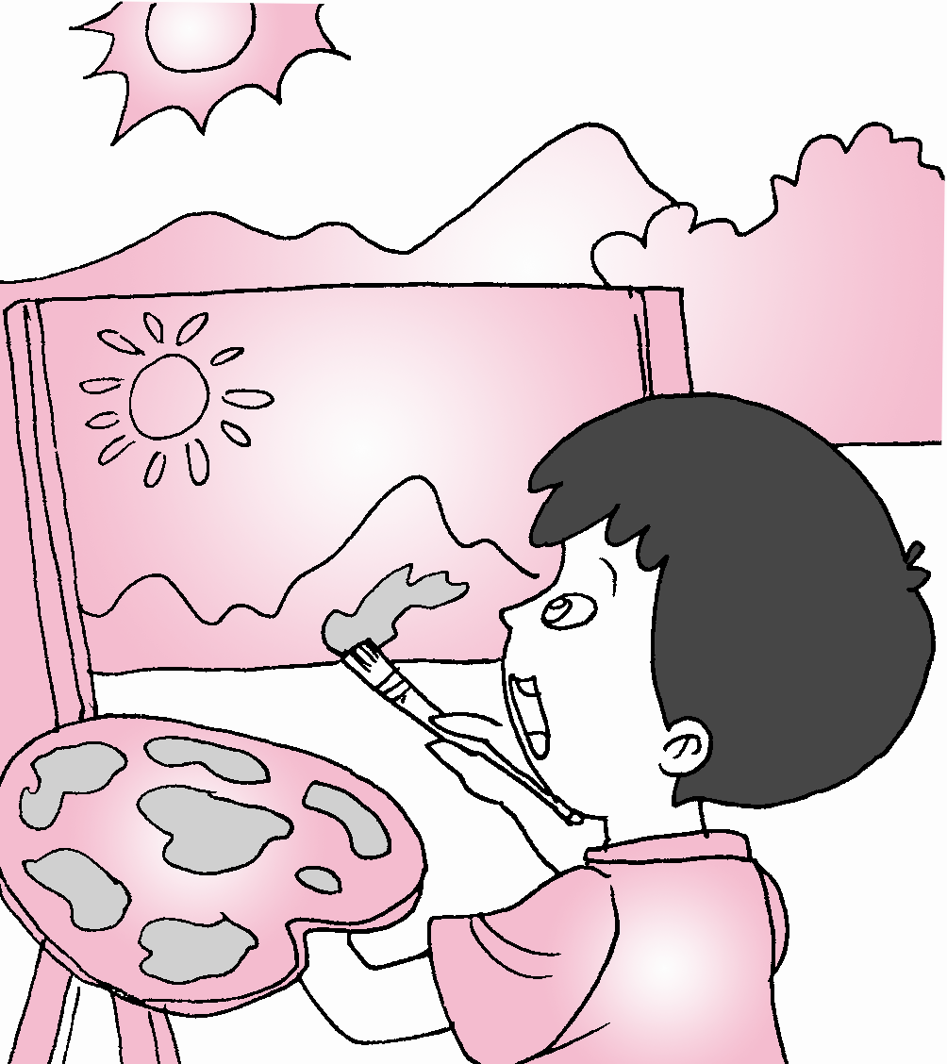


A. B. C.
答案：___________
十、连词成句。(10分)
1. be, pal, I, also, pen, Can, his (?)
___________________________
2. very, in, Chinese, is, He, interested, food (.)
___________________________
3. on, is, There, music, Sunday, class, a (.)
___________________________
4. teaches, to, make, He, robots, students (.)
___________________________
5. see, new, Come, pal, and, my, pen (.)
___________________________
十一、读一读，选一选正确的答案。(10分)
Kitty is my new pen pal. She 1 in Canada. 2 father is a teacher. He 3 to work by bus. Her mother is a nurse. She works in a 4 . She goes to work by subway. Kitty likes 5 and drawing pictures. She usually draws pictures on Sundays.
( ) 1. A. live B. lives C. living
( ) 2. A. She B. Her C. His
( ) 3. A. goes B. go C. going
( ) 4. A. cinema B. hospital C. school
( ) 5. A. sings B. sing C. singing
十二、小作文。(10分)
同学们，你有笔友吗？你了解他吗？试着写一篇小作文，从兴趣、爱好等方面介绍一下你的笔友。
__________________________________________________________________________________________________________________________________________________________________________________________________________________________________________________________________________________________________________________________________________________________________________________________________________________________________________________________________________________________________________________________________________

Unit 4测试卷
听力材料
一、听录音，给下列图片排序。
1. make salad 2. play football 3. go hiking 4. do kung fu 5. fly kites
二、听录音，选择你所听到的句子。
1. Do you want to cook?
2. The cat just sleeps.
3. I like playing sports.
4. John likes flying kites and singing English songs.
5. I want to eat some cake.
三、听录音，选择正确的答语。
1. What’s her hobby?
2. Does he live in Australia?
3. Let’s go together.
4. Does she go to work by bus?
5. What does Sarah like?
四、听录音，判断下列句子的正(T)误(F)。
Sam is my pen pal. He is from Canada. He likes Chinese kung fu. His father likes listening to music. He can make Chinese food. His mother is a teacher. She likes playing the pipa. They love China very much.
参考答案
一、4 5 2 3 1
二、1. A 2. B 3. B 4. A 5. B
三、1. B 2. C 3. A 4. C 5. C
四、1. F 2. F 3. F 4. T 5. T
五、1. C 2. C 3. B 4. A 5. C
六、1. C 2. B 3. C 4. A 5. B
七、1. D 2. B 3. C 4. A 5. E
八、1. What is 2. singing; dancing 3. are; doing 4. interested in 5. to sleep
九、A
十、1. Can I also be his pen pal?
2. He is very interested in Chinese food.
3. There is a music class on Sunday.
4. He teaches students to make robots.
5. Come and see my new pen pal.
十一、1. B 2. B 3. A 4. B 5. C
十二、例文:
I have a pen pal. His name is Tom. Tom is from Canada, but he lives in Beijing now. He is twelve years old. Tom likes Chinese very much. He reads Chinese every morning. Tom likes swimming. He often swims on the weekend. He also likes playing basketball. We often play basketball at school.



