教学资料范本

小学三年级英语1 Unit 3单元检测(含听力材料)

编 辑：__________________

时 间：__________________

Listening Part(听力部分)
I. Listen and number(根据你听到的内容给下面的图片标上序号)
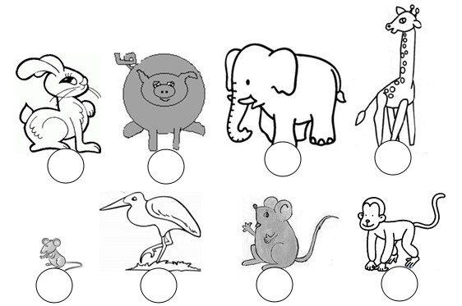
II. Listen and tick.（听一听，根据听到的内容判断图片表达的意思是否正确）
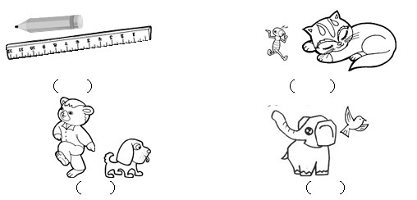
III. Listen and circle (听一听，圈出恰当的图片)

- 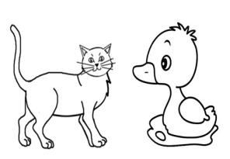 2. 3.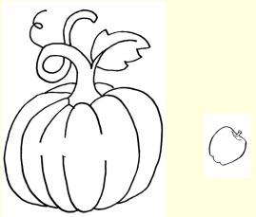 4.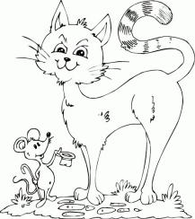

- 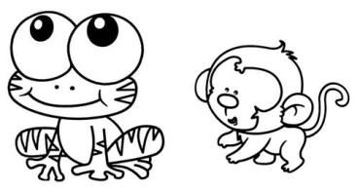 6.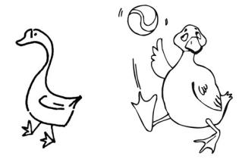 7.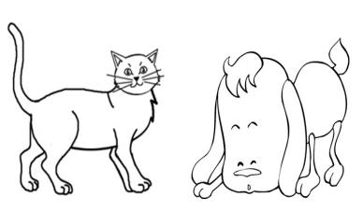
IV. Listen and circle. (听一听，圈出你所听到的单词)
1. fat short leg
2. thin big tall
3. long small so
4. fat thin tall
5. giraffe children deer
V. Listen and number. (听一听，根据你听到的内容给下面句子标上序号)

( ) Where are you from?
( ) It has a long nose and short tail.
( ) Who’s that man?
( ) She’s my mother.
( ) It’s so tall.
( ) No, he isn’t.
VI. Listen and number.(听一听，给每组中的单词排列顺序）
- 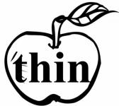

2.   

- 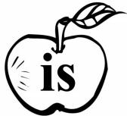

4. 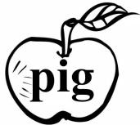 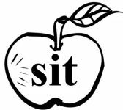 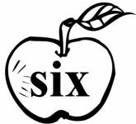

VII. Listen and write. (听一听，写一写）
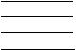

Writing Part（笔试部分）
VIII. Read and circle.(读一读，圈出不同类的单词）
1. fat thin he
2. she tall big
3. long it short
4. big leg tall
5. cat pig fat
Read and choose (读一读, 选择正确的图画，把图画的序号填在括号内).
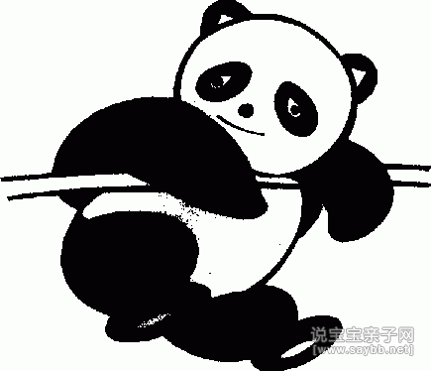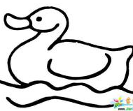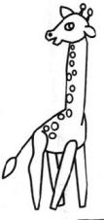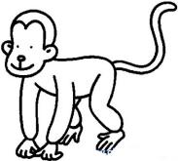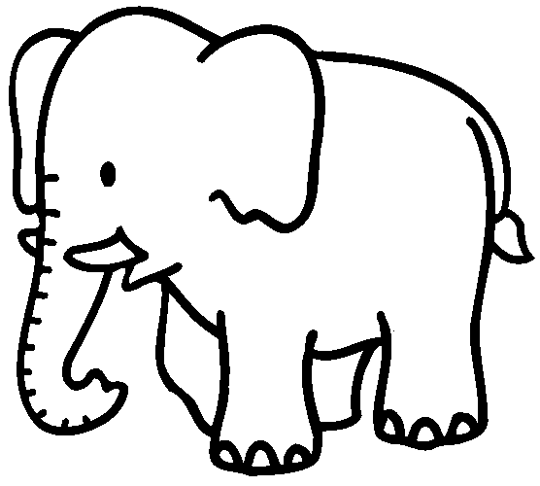
A B C D E
( )1. This is a monkey. It has a long tail. It’s thin.
( )2. Look at the giraffe . It has long legs and a small head. It’s so tall.
( )3. This is a panda.It has big eyes and a short tail. It’s black and white.
( )4. Look at the elephant It has a big body and a long nose. It is so fat.
( )5. I have a duck. It has a big mouth. It’s small.
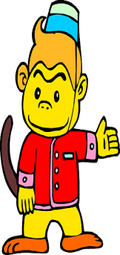
Read, guess and match (读一读，猜一猜，连一连).
I’m I have a small nose and big eyes. And I have a long tail. I like fish.

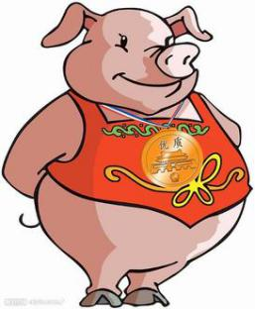

I’m thin.I have small eyes and small ears.I have a long tail . I like bananas.

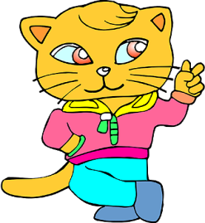
I’m small. I have a small nose and a small mouth.I have small eyes, too.

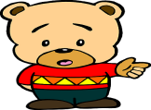
I’m big. I have a fat body. And I have a big mouth and a short tail.

Unit 3听力材料
I. Listen and number(根据你听到的内容给下面的图片标上序号)
1. It’s small. It has a long tail.
2. It has long ears and a short tail.
3. It has a long mouth ans long legs.
4. It’s fat. It has a long tail and big ears.
5. It’s thin. It has a long tail and small ears.
6. It’s so big. It has a long nose and big ears.
7. It’s so tall. It has a long neck.（脖子）
8. It’s big and fat. It has short legs.
II. Listen and tick.（听一听，根据听到的内容判断图片表达的意思是否正确）
1. The pencil is long. The ruler is short.
2. The ant is thin. The cat is fat.
3. The bear is tall. The dog is short.
4. The elephant is small. The bird is big.
III. Listen and circle (听一听，圈出恰当的图片)
1. It has a short tail.
2. He is tall.
3. It is so small.
4. It is tall. It has long tail.
5. It has big eyes.
6. It is fat.
7. It has long ears and short tail.
IV. Listen and circle. (听一听，圈出你所听到的单词)
1. fat 2. big 3. long 4. tall 5. children
V. Listen and number. (听一听，根据你听到的内容给下面句子标上序号)
1. Who’s that man?
2. She’s my mother.

4. It has a long nose and short tail.
5. Where are you from?
6. No, he isn’t.
7. It’s so tall.
VI. Listen and number.(听一听，给每组中的单词排列顺序）
1. big fish thin 2. him in his
3. milk it is 4. sit pig six
VII. Listen and write. (听一听，写一写）
1. /b/--/i/--/g/----big 2. /s/--/i/--/ks/---six
3. /p/--/i/--/g/----pig 4. /m/--/i/--/l/--/k/----milk

