PEP四下小学文化素质测试
四年级英语期末测评
（总星数：100☆ 时间：40分钟）
题号 | 一 | 二 | 三 | 四 | 五 | 六 | 七 | 八 | 九 | 十 | 卷面 | 总☆
☆数

同学们，准备好了吗？我们先来做听力部分吧！

听力部分（50☆）
【温馨提示：听之前，一定先看一遍听力部分的图和题，这样听起来就容易多了】
一、听录音，根据你所听到的内容，把选项填在括号内（10☆）
( ) 1. A. what for B. weather report C. all right
( ) 2. A. canteen B. sixty C. donkey
( ) 3. A. whose B. those C. shoes
( ) 4. A. teacher’s office B. music room C. P.E. class
( ) 5. A. cool B. floor C. colourful

二、听录音，根据听到的顺序给下面的图片标上序号。(10☆)


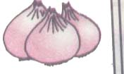
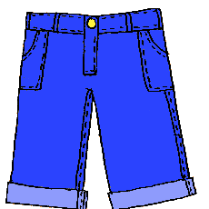

( ) ( ) ( ) ( ) ( )
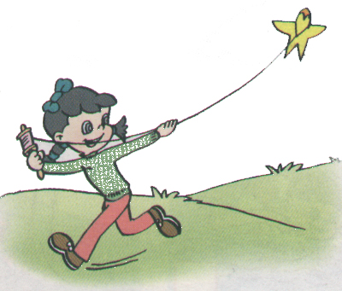
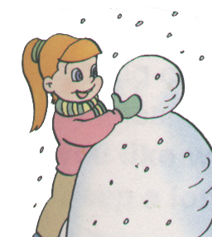
三、听录音，在正确答案上打“√”（10☆）
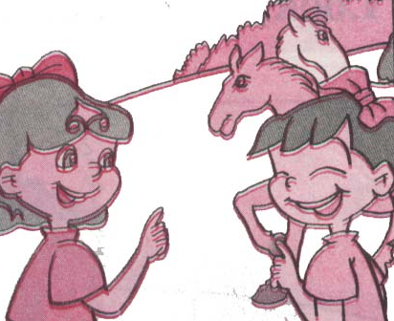
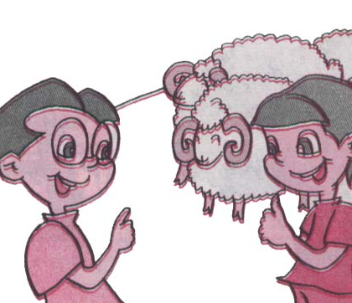
1． 2.

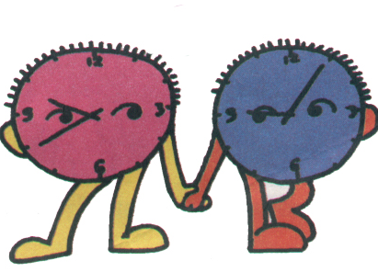
A B A B
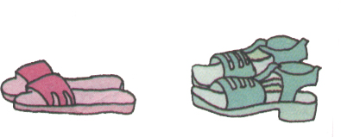


3． 4. 5.

A B A B A B
四、听录音，选答语（10☆）
( ) 1. A. Thank you. B. It’s on the second floor. C. It’s blue.
( ) 2. A. Yes, I am. B. No, it’s a map. C. It’s your baby brother’s.
( ) 3. A. It’s nine ten. B. They are hens. C. They are thirty-five yuan.
( ) 4. A. Two. B. No, they aren’t. C. They are goats.
( ) 5. A. Yes, you can. B. It’s too expensive. C. Yes, I want a pair of shoes.
五、听录音，写单词，完成句子（10☆）
1. We have four __________ in our classroom.
2. My T-shirt is __________ .
3. It’s __________ today.
4. I want ten _________.
5. There are ____________-one goats.
接下来用你的耐心和细心，体验采摘知识果实带来的开心吧！
笔试部分（40☆）
六、挑挑选选。(10☆)
有一个是与其它三个不同类的，请选出来，并填到前面括号里。
( ) 1. A. this B. that C. the D. those
( ) 2. A. breakfast B. lunch C. dinner D. weather
( ) 3. A. class B. Chinese C. English D. music
( ) 4. A. sweater B. jeans C. shorts D. these
( ) 5. A. rainy B. pretty C. cloudy D. windy
( ) 6. A. floor B. my C. your D. our
( ) 7. A. sixty B. many C. ninety D. seventy
( ) 8. A. lamb B. cow C. farm D. pig
( ) 9. A. tomato B. carrot C. cucumber D. matter
( ) 10. A. red B. colour C. white D. green
七、读读写写 根据提示完成句子。(5☆)
1. Is this a _____________________ (西瓜)？
2. I have a new __________ (连衣裙) for my birthday party.
3. It’s __________ (暖和的) today.
座号
4. The shirt is _________ (长的).
5. –Are they __________ (鸭子)? –No, they aren’t.
八、我问你答，情景对话(10☆)
从右边的答语中选择正确选项填在左边问句后的括号内。
1. Is that a picture? ( )
2. Is this your skirt, Alice? ( )
3. What’s the weather like there? ( )
4. It’s hot. Can I wear my T-shirt?( )
5. How much are they? ( )
6. What colour is it? ( )
7. What are they? ( )
8. Are they all right? ( )
9. How many cows do you have? ( )
10. Here’s your coat, Zoom. ( )
A. No, it’s a map.
B. Thank you. Thank you.
C. One hundred.
D. They are hens.
E.They are thirty-five yuan.
F. It’s cool.
G. Yes, it is.
H. Yes, you can.
I. Yes, they are.
J. Blue.

九、排词成句。按照正确顺序排列下列单词。(5☆)
1. my is computer This (.)
__________________________________________
__________________________________________
__________________________________________
__________________________________________
2. o’clock It’s two (.)
__________________________________________
__________________________________________
__________________________________________
__________________________________________
3. class for math time It’s (.)
__________________________________________
__________________________________________
__________________________________________
__________________________________________
4. football Let’s play (.)
__________________________________________
__________________________________________
__________________________________________
__________________________________________
5. it is much How (?)
__________________________________________
__________________________________________
__________________________________________
__________________________________________
十、阅读与理解。(10☆)
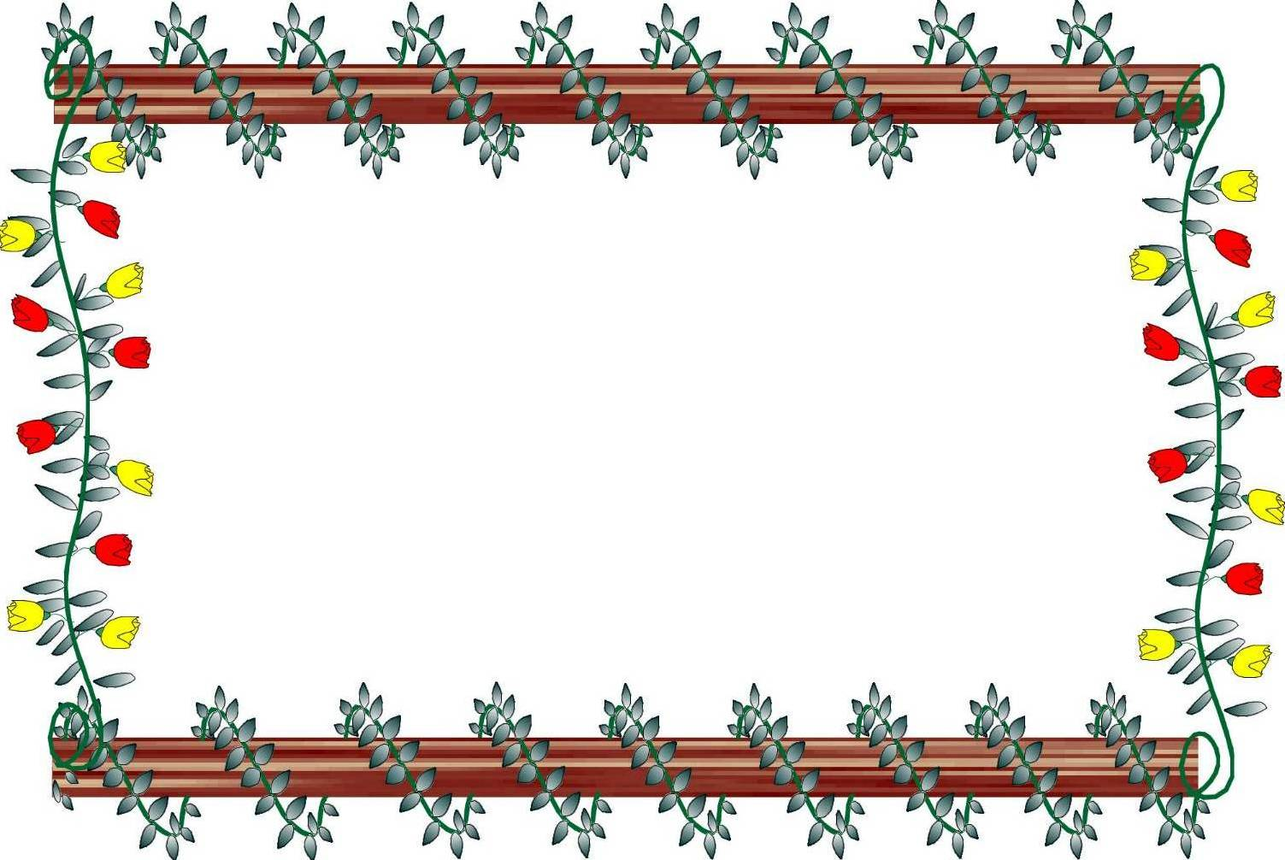

Dear Grandma,
Thank you for the new shorts. They are cool!
It’s hot in Beijing. It’s sunny too. I can wear my shorts
and T-shirt. I have a new jacket. My old jacket is too
small. I want to buy a hat. It is fifty yuan. It’s too
expensive.
What’s the weather like at the farm? Is it warm?
How many new ducks are there?
Love,
John

阅读John写给奶奶的信，判断正（√）误（×）。
1. It is cool in Beijing. ( )
2. John has a new jacket. ( )
3. Grandma is at the farm. ( )
4. The jacket is fifty yuan. ( )
5. It’s sunny in Beijing. ( )

同学们，在四年级的学习中肯定留下了你精彩
的表现，再仔细检查检查，你会更出色!

四年级听力原稿及试题参考答案
（请阅卷老师一定先做一遍，再批阅！）
一、听录音，根据你所听到的内容，把选项填在括号内（每小题听两遍）
1. what for 2. sixty 3. shoes 4. teacher’s office 5. floor ABCAB
二、听录音，根据听到的顺序给图片标上序号。31452
1. It is hot in Shenzhen. I go swimming.
2. Look! This is the library. We have many picture-books.
3. I’m hungry, Mom. Oh, it’s 12 o’clock. It’s time for lunch.
4. Are they potatoes? No, they are onions.
5. How much are the pants? They are 35 yuan.
三、听录音，在正确答案上打“√”（每小题听两遍 ）BAAAB
1．–What are these? –They are sheep.
2. –In Beijing it’s sunny and warm. – I go out and fly a kite.
3. –Can I help you? –Yes, please. I want a pair of slippers.
4. – It’s 9:40. It’s time to go to bed. –Good night. Mom.
5. –How many bananas can you see? –I can see 4.
四、听录音，选答语（每小题听两遍 ）BCABC
1. Where is the library? 2. Whose is it? 3. What time is it?
4. Are they sheep? 5. Can I help you?
五、听录音，写单词
1. We have four lights in our classroom. 2. My T-shirt is yellow.
3. It’s sunny today. 4. I want ten oranges.
5. There are twenty-one goats.
六、CDADB ABCDD
七、1. watermelon 2. dress 3. warm 4.long 5. ducks
八、1. A 2. G 3. F 4. H 5. E 6. J 7. D 8. I 9. C 10. B
九、1. This is my computer. 2. It’s two o’clock.
3. It’s time for math class. 4. Let’s play football.
5. How much is it?
十、1. ×2. √3. √4. ×5. √

