人教版八年级英语上册期中试卷含听力答案及材料
时间；90分钟 满分；120分
第一部分. 听力（20分）
I. 听句子，选出与句子内容一致的图画.每句读两遍（5分）
( )1. 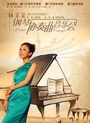.  
A B C
( )2. 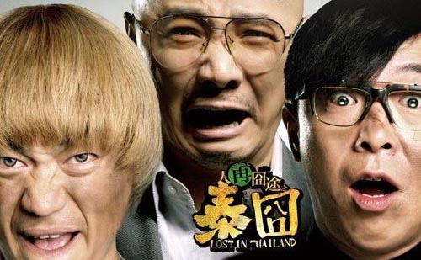 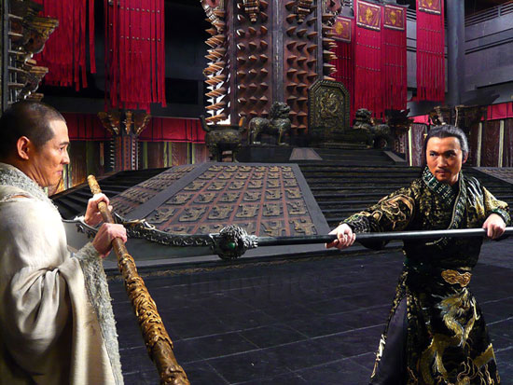 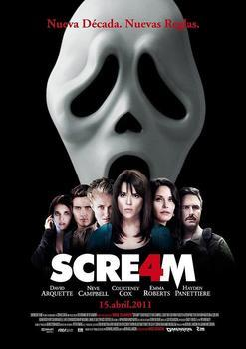
A. B. C.
( ) 3. 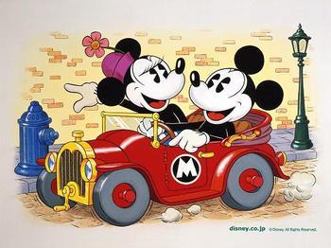  
A. B. C.
( ) 4.   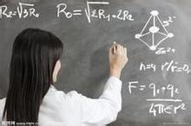
A. B. C.
( ) 5.  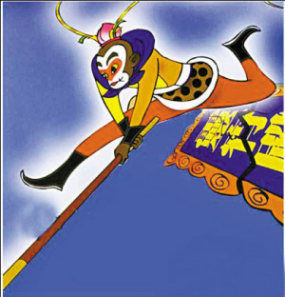 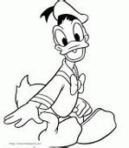
A. B. C.
II. 听问句，选择正确答语.每句读两遍.（5分）
( )6、What color are Lisa’s clothes ?
A. Red B. Blue C. Brown
( )7、Who dances better?
A. Amy B. Betty C. May
( )8、Who thinks the food is the most expensive ?
A. Jack’s brother B. The girl C. Jack
( )9、 What can Peter do ?
A. Run very fast. B. Sing fast songs well. C. Write songs himself.
( )10、When does Bob want to go to the movies ?
A. This evening. B. Tomorrow morning. C. Tomorrow evening.
III．听对话，选择最佳答案. 每个对话读两遍.（5分）
听第一段对话，回答11-12小题.
( ) 11. Who is the tallest in Kevin’s class?
A. Kevin. B. Bill. C. Lucy.
( ) 12. When was the talent show?
A. Last Monday. B. Last Tuesday. C. Last Thursday.
听第二段对话，回答第13-15小题.
( )13. How does Tina look?
A. Tired. B. Excited C. Sad
( )14. What movie did Tina watch yesterday?

( )15. Where did Tina watch the movie?
A. In the cinema B. At her home C. At the boy’s home
IV．听长对话，完成表格，每空一词.对话读三遍.（5分）
Time | On(16)________
People | Linda, Ted and Julie.
Things they did | They went to (17)__________ clothes stores and bought some clothes in the  (18)________ store in the morning.  They Went to a restaurant have lunch. The food was (19)_________ but not delicious.  Watched an action movie and a (n)(20)________ show in the afternoon.

第二部分： 知识应用、阅读及写作（100分）：
Ⅰ. 单项选择（10分）
( ) 1. Star Wars is action movie.
A. a B. an C. the
( ) 2. Here the results the student activities.
A. is, with B. are, of C. being, of
( ) 3. - do they exercise? - Once a week.
A. How soon B. How often C. How long
( ) 4. Mr.Green dinner yesterday.
A. doesn’t have B. didn’t have C. didn’t has
( ) 5. Timmy tells me that you have read on the Internet.
A. something interesting B. anything interested C. interested something
( ) 6. It’s hotter than yesterday.
A. most B. more C. much
( ) 7. Tom’s joke made all of us .
A. laugh B. laughing C. to laugh
( ) 8. Which season do you think is the in a year?
A. best B. better C. well
( ) 9. it never snows, I still feel cold.
A. Although, but B. But, although C. Though, /
( ) 10. What do you soap operas?
A. think of B. look at C. look like

Ⅱ. 完形填空（10分）
Sports and games are good 11 our health. They can 12 us strong, stop us from getting
13 fat and keep us 14 and happy. Especially（特别是）, they can help people who work with their brains（大脑） 15 of the day to study better, for sports and games let people 16 their bodies.
They make our life richer and more colorful. If we 17 not have strong body, we can 18 do things well. So persons of all ages enjoy 19 and taking part in 20 kinds of sports – track and field （田径）, swimming, skateboarding, and ball games.
( ) 11. A. at B. for C. to
( ) 12. A. make B. find C. do
( ) 13. A. to B. too C. a lot of
( ) 14. A. health B. healthy C. unhealthy
( ) 15. A. all B. most C. some
( ) 16. A. exercise B. to exercise C. exercising
( ) 17. A. are B. do C. don’t
( ) 18. A. always B. hard C. hardly
( ) 19. A. seeing B. watching C. to watch
( ) 20. A. difference B. different C. difficult

Ⅲ. 阅读理解（40分，每题2分）

（A）阅读短文，从每题所给的选项中选出最佳选项回答问题或完成句子.
We each have a memory. That’s why we can still remember things after a long time. Some people have very good memories and they can easily learn many things by heart, but some people can only remember things when they say or do the again and again. Many of the great men of the world have got surprising memories.
A good memory is a great help in learning languages. Everybody learns his mother language when he is a small child. He hears the sounds, remembers them and then he learns to speak. Some children are living with their parents in foreign countries. They can learn two languages as easily as one because they hear， remember and speak two languages every day. In school it is not so easy to learn a foreign language because the pupils have so little time for it, and they are busy with other subjects, too.

( ) 21. Some people can easily learn many things by heart because __________ .
A. they always sleep well B. they often eat good foot
C. they read a lot of books D. they have very good memories
( ) 22. Everybody learns his mother language __________ .
A. at the age of six B. when he is a small child
C. after he goes to school D. ]when he can read and write
( ) 23. Before a child can speak, he must __________ .
A. read and write B. make sentences
C. hear and remember the sounds D. think hard
( ) 24. In school the pupils can’t learn a foreign language easily because __________ .
A. they have no good memories B. they have no good teachers
C. they don’t like it D. they are busy with other subjects
( ) 2
A. if you have a lot of good food B. if you do more and more exercises
C. if you do morning exercises every day D. if you get up early

（B）阅读短文，从每题所给的选项中选出最佳选项回答问题或完成句子.
Many people like to travel by plane , but I don't like it because an airport(飞机场) is usually far from the city. You have to get to early and wait for hours for the plane to take off and it is often late. You can’t open the windows. You can’t choose the food. Planes are fast, but they still take hours to go out the airport and into the city.
I like traveling by train. I think trains are safe. Train stations are usually in cities. When you are late for a train, you can catch another one. You can walk around in the train and open the windows. You can see many interesting things on your way. I know it takes a little more time.
I also like cars. You can start your journey when you want to, and you don’t need to get to train station or bus stop. Also you can carry many things with you in a car. But sometimes there are too many cars on the road.
( ) 26. Why do many people like to travel by plane?
A. Because it’s fast. B. Because it’s safe
C. Because you can walk around in the plane. D. Because it’s cheap.
( ) 27. Which is NOT the good thing about the train?
A. It is safe B. It takes a little more time.
C. You can open the windows. D. You can walk around in the train.
( ) 28. If you want to take a lot of things with you, what do you take to go out?
A. A bus. B. A car. C. A train. D. A bike
( ) 29. What is the bad thing about the car?
A. You needn’t go to a station.
B. You can start your journey when you want to.
C. There are too many cars on the road.
D. You needn’t go to a bus stop.
( )30. What does the writer think of the plane?
A. He thinks it takes a lot of time to go to and get out of the airport.
B. He likes to take a train because it takes a little more time.
C. He likes to take a car because he has a car.
D. He likes to take a plane because it’s fast.

（Ｃ）阅读短文，判断下列句子的正误（正确T，错误F）
One day a woman wrote to a doctor to ask him to have dinner at her house. The doctor wrote an answer, but he wrote so carelessly that the woman couldn’t read it.
“What should I do?” she asked her husband, “I don’I don’t want to ring him up and tell him that I can’t read his writing.”
Her husband thought for a while and said, “Take it to the chemist（药剂师）. He will be able to read it.”
The woman went to the chemist’s shop and showed the doctor’s note to the chemist. He looked at it very carefully. Then he put on his glasses and looked at the note more closely.
“Could you wait for a moment, madam?” he said.
He went to the back of his shop. After a few minutes he returned. He was carrying a bottle. He gave the bottle to the woman, and said, “Take this medicine three times a day.”
( ) 31. The woman wanted to have dinner at the doctor’s house.
( ) 32. The woman didn’the doctor wrote his note too carelessly for her to read.
( ) 33. The woman’s husband asked her to take the note to the chemist because he thought the chemist could read it.
( ) 34. The doctor and the chemist saved the woman’s life two years ago.
( ) 35. The story tells us we mustn’t pretend（假装）to know what we don’t know.

(D) 摘录要点. 阅读下面的短文，根据短文内容完成表格，将第36-40小题的信息补充完整.每空不超过3个单词.
The English usually have four meals a day: breakfast, lunch , tea (5:00) and dinner. Breakfast can be a full “English breakfast” of cornflakes with milk and sugar, or bacon and eggs, toast and marmalade, tea of coffee. Some people, however, have just a cup of tea or coffee with a toast of something similar. This is usually a “continental breakfast (大陆式早餐)”.
At midday everything is stopped for lunch. Most offices and small shops are closed for an hour and the city pavements are full of people on their way to cafes, coffee bars, restaurants. All workers usually eat in their factories.
The English like what they call “good plain food”. They must be able to recognize what they are eating. Usually they like steak, roast beef, Yorkshire pudding and fish and chips.
Afternoon tea is taken at about 5:00, but it can hardly be called a meal, it is a cup of tea and cake or biscuits. At the weekends afternoon tea is a special occasion (场合). Friends and visitors are often invited to have a chat over a cup of tea.
Dinner is the most important meal of the day. It is usually eaten at 7:00. the first course may be soup. The main course will often be fish or meat, perhaps the traditional roast beef of old England, and a lot of vegetables. The next course will be something sweet and often cooked, such as fruit pie. Last of all there may be cheese, often with biscuits.
There are 36. ____________ meals | for most English people
The English usually have their lunch | outside, not in their 37. ____________.
Good plain food is a kind of 38. ____________ | for the English.
People can talk with each other while | they are having their afternoon 39. _______.
From the passage we know the English | have four course during their 40. _________

Ⅳ. 补全对话（10分）选择最佳答语补全对话
A: Hello , Jane . Long time no see.
B : Hi, Tony. Yes, I was on vaction last month.
A : 41___________
B: It was great .
A: 42______________
B : Yes, I went with my father.
A : Where did you go ?
B : 43____________ Then we went to Scotland .
A : 44______________
B : Terrible . It always rained .
A : 45______________

A . How was your vacation? B. It is very hot there ,isn’t it?
C . Well, we spent one week in London . D. How was the weather there?
E . Did you take any pictures? F. Did you go with anyone?

Ⅴ. 词形转换.根据所提供的句子意思，用所给单词的正确形式填空，使句子意思完整.
46. My sister often (watch) TV on weekends.
47. The movie was very (bore). I slept when I watched it.
48. He brushes his teeth (two) a day.
49. It’s important for us (learn) Enlish well.
50. I can’t work as (hard) as Jim does.
51. They’re twins, but they are (difference) from each other.
52. We should take it (serious).
53. The young boy enjoys (tell) jokes.
54. I don’t like scary movies, but I like
55. Do you plan
Ⅵ. 英汉互译（10分）
56. 你们去年去哪度假的？
Where you go vacation last year?
52. 在上学时的晚上，他几乎不看电视.
He watches TV on school nights.
53. 玛丽比凯特更外向得多.
Mary is much than Kate.
54. 谢谢你告诉我去邮局的路.
telling me the way to the post office.
55. 这是一个多么有趣的故事啊！
interesting story this is!

Ⅶ. 书面表达.（10分）
请你谈谈你和你的好朋友的相同点和区别.从外表、性格和爱好三方面描述.（词数：60词左右）

人教版八年级英语（上）期中试卷 听力参考答案
第一部分听力参考答案：
1-5 BABCA 6-10 ABCBA 11-15 BBACA
16. Saturday 17. three 18. third 19. cheap 20. talent

人教版八年级英语（上）期中试卷 听力材料
Ⅰ．听句子，选出与句子内容一致的图画.每句读两遍
1. Do you want to watch the news?
2.
3. My mother doesn’t mind sports shows.
4. Sally hopes to be a teacher one day.
5. Many children like Mickey.
Ⅱ．听对话，选择正确答语.每句读两遍.
6. W：Is that girl in red clothes Nelly?
M: No, that is Lisa. Nelly has brown hair.
7. M: I like Amy. She sings well. What about you, May?
W: I think so, too. But Betty dances better than Amy.
8. W: The food in this restaurant is the most delicious in our town, Jack.
M: Yes , But it’s the most expensive ,too.
9. W: Who is the best singer in your school?
M: Peter. He can sing fast songs very well.
10. M: Hi, Lily . Let’s go to the movies this evening . It’
W: I don’y’re boring .
Ⅲ．听对话，根据对话内容选择正确答案并将其标号填在题前的括号内.对话读三遍.
听第一段对话，回答第11至12小题.
W: Are you the tallest in your class , Kevin?
M: No, Bill is the tallest .but I dance better than Bill.
W: Did you win a prize in the talent show last Tuesday?
M: Yes , Lucy . I danced with my dog . We won the prize for the funniest performers.
W: That sounds interesting.
听第二段对话，回答13至15小题.
M: You look tired , Tina . Why ?
W: I didn’t sleep well last night .
M: Why ?
W: I watched a scary movie yesterday evening .
M: Did you watch it in the City Cinema?
W: Yes .How do you know that ?
M: I went there yesterday evening, too.
Ⅳ. 听短文，完成表格，每空一词.对话读三遍.
It’s Saturday today. Linda ,Ted and Julie had no lessons. In the morning ,they went shopping. They went to three clothes stores and bought some clothes in the third store. That clothes store had the best service . Then they went to the nearest restaurant for lunch. The food was cheap but not delicious. In the afternoon , they went to a movie. It’s an action movie . It's Ted’s favorite . After that ,they watched a talent show in a theater. At about 4:30, they took a bus home . They were tired but happy.

