石埠子小学六年级英语试题
一、听音，选出句子中出现的单词或词组，将其选项填入括号内。
（ ）1. A. pencil B. pen friend （ ）2. A. pleased B. please
（ ）3. A. French B. from（ ）4. A. different B. difficult
（ ）5. A. China B. Chinese
二、听音，判断下列句子是否与你听到的内容相符， “√”， “×”。
（ ）1. Li Lei is watching a new DVD. （ ）2.The tiger is eating.
（ ）3.He doesn’t like fish. （ ）4.I always play computer games.
（ ）5.I never play basketball. 新|课 |标|第 |一| 网
三、听音，根据录音内容选词填空。
Pandas can _____ (A. swim B. dance). They eat bamboo, flowers, grass and ____ (A. small B. big)animals. They eat for_____ (A.11 B.12)hours a day. Pandas don’t _____ (A. sleep B. sleeping)all day in winter. In summer, they go _____ (A. up B. down) the mountains.
四、听音，选出你听到的句子。
（ ）1. A. I want to visit China. B. She wants to visit Canada.
（ ）2. A. It’s got a beautiful lake. B. It’s a beautiful lake.
（ ）3. A. Open you book. B. Open the door.
（ ）4. A. Don’t turn right here! B. Don’t ride your bike here!
（ ）5. A. Go! It’s green. B. Stop! Don’t cross. X k B 1 . c o m
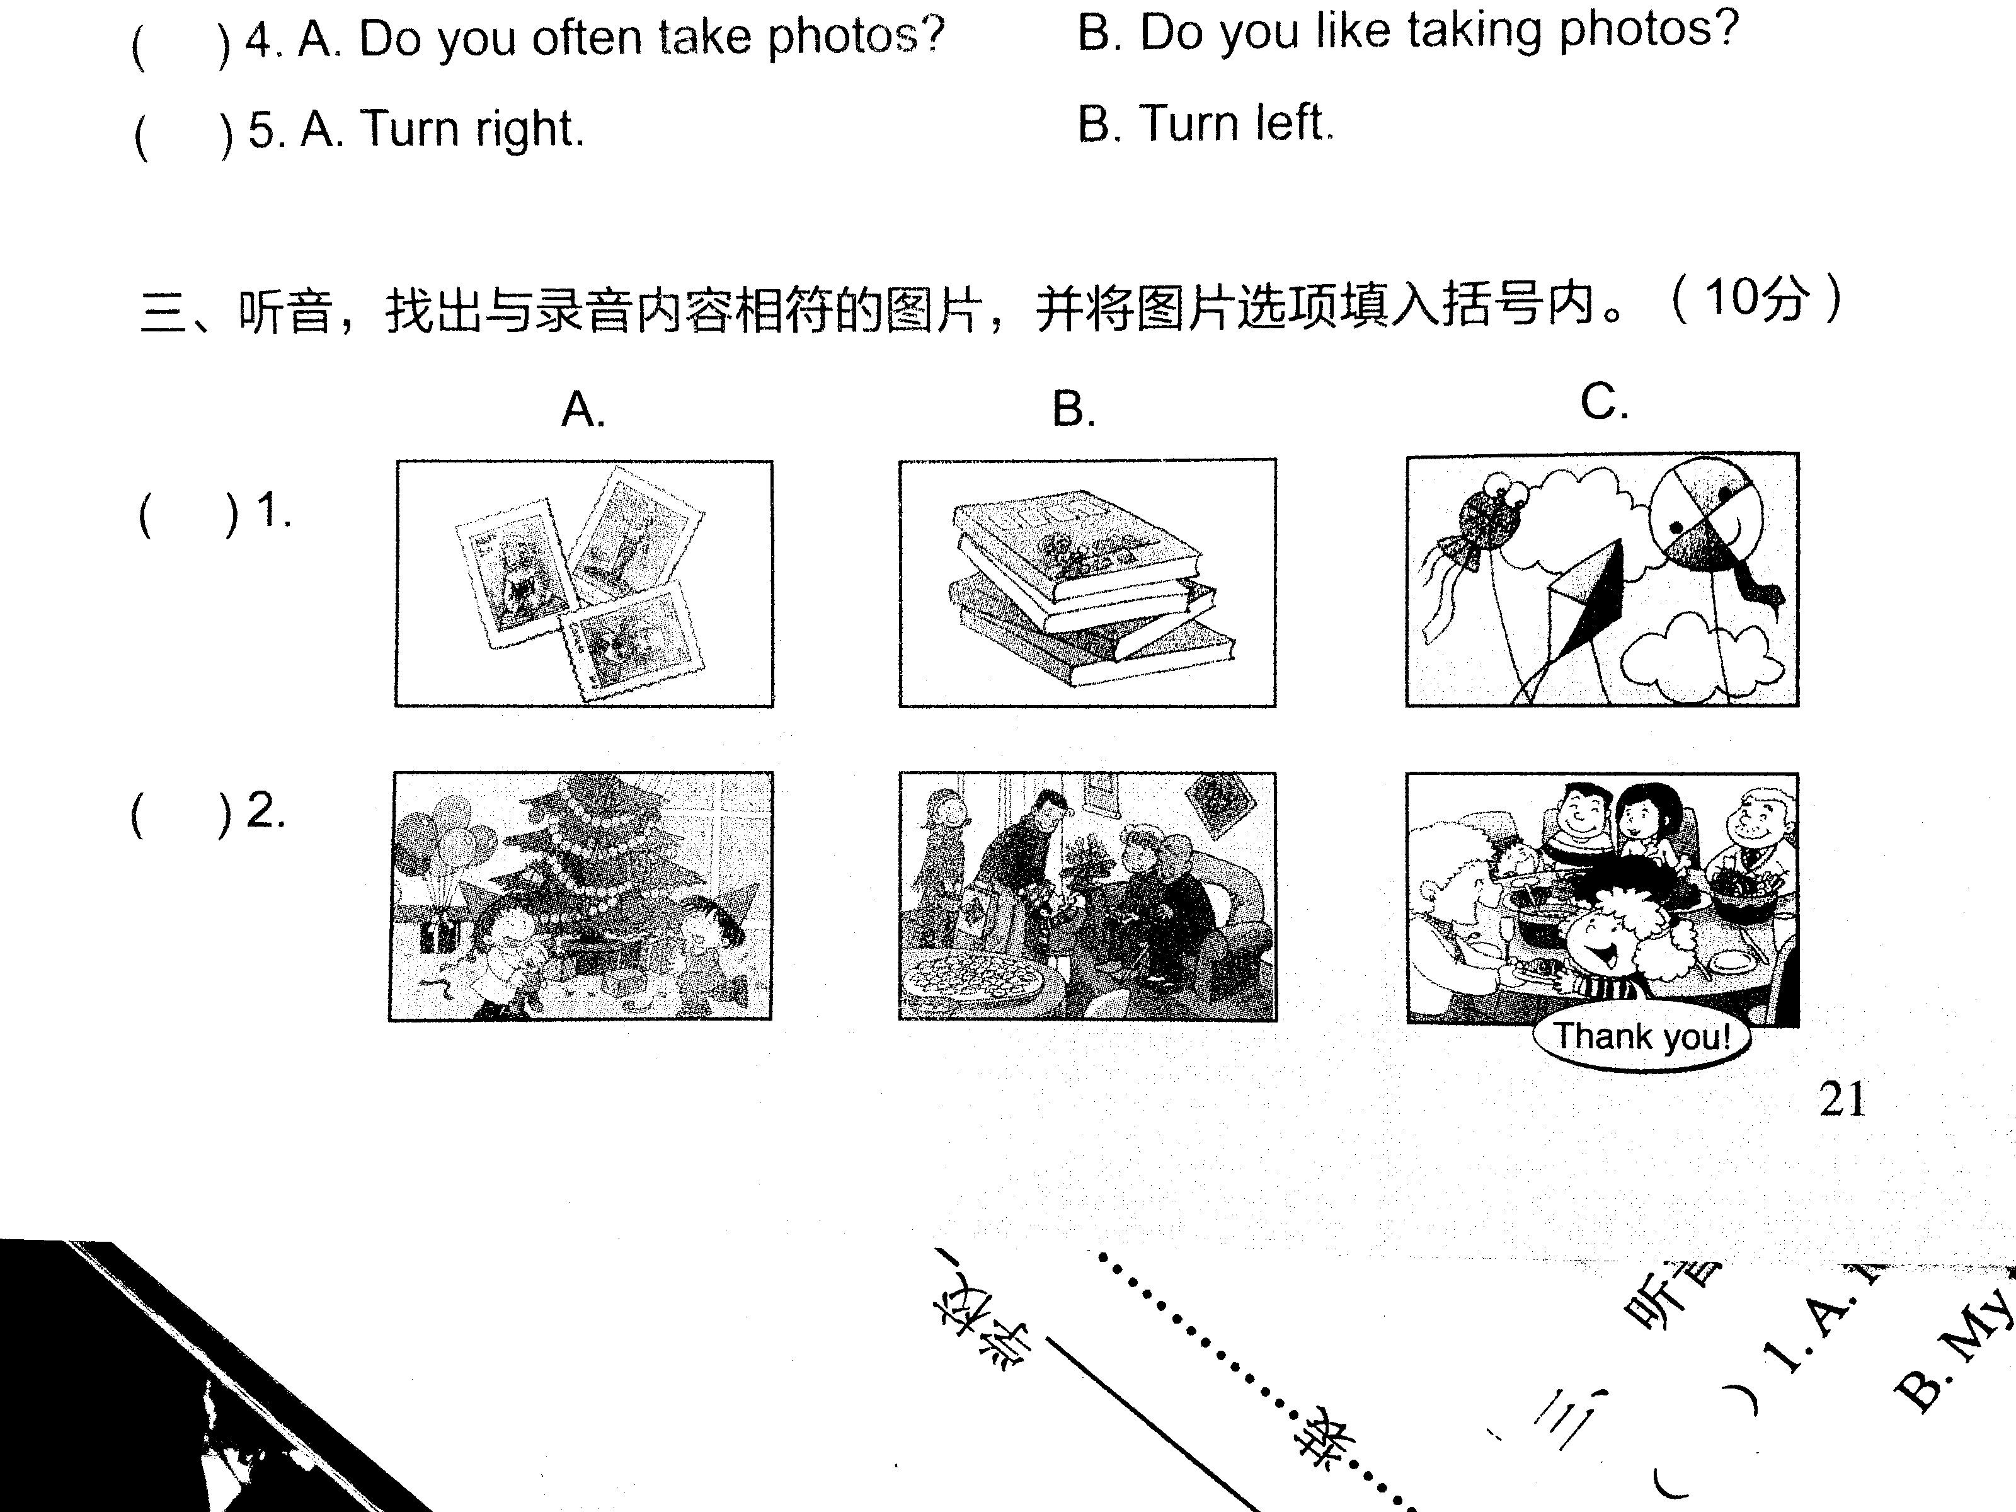
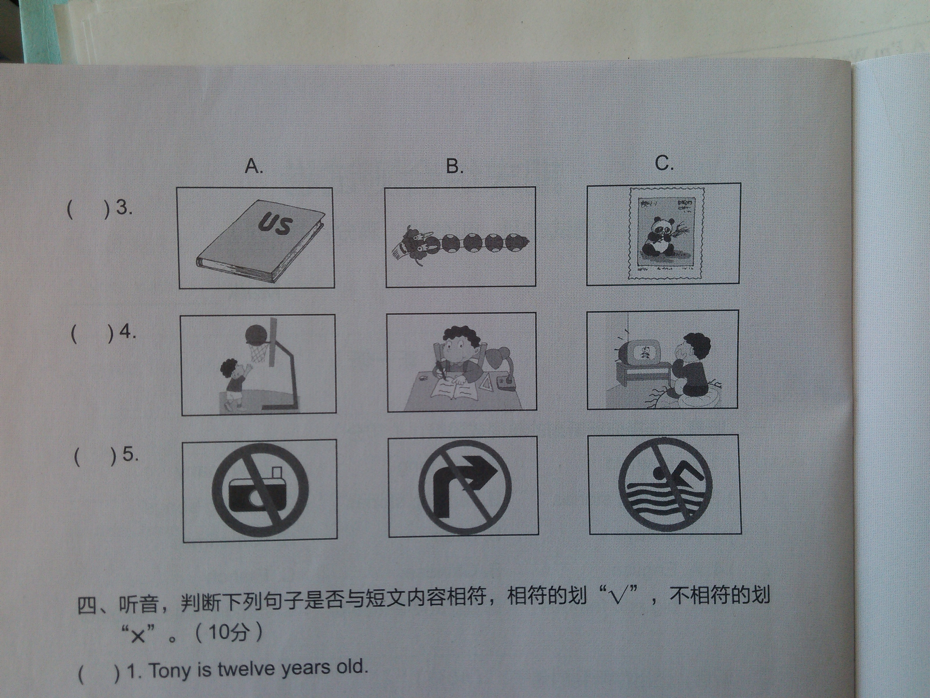
五、听音，找出与录音内容相符的图片，并将图片选项填入括号内。

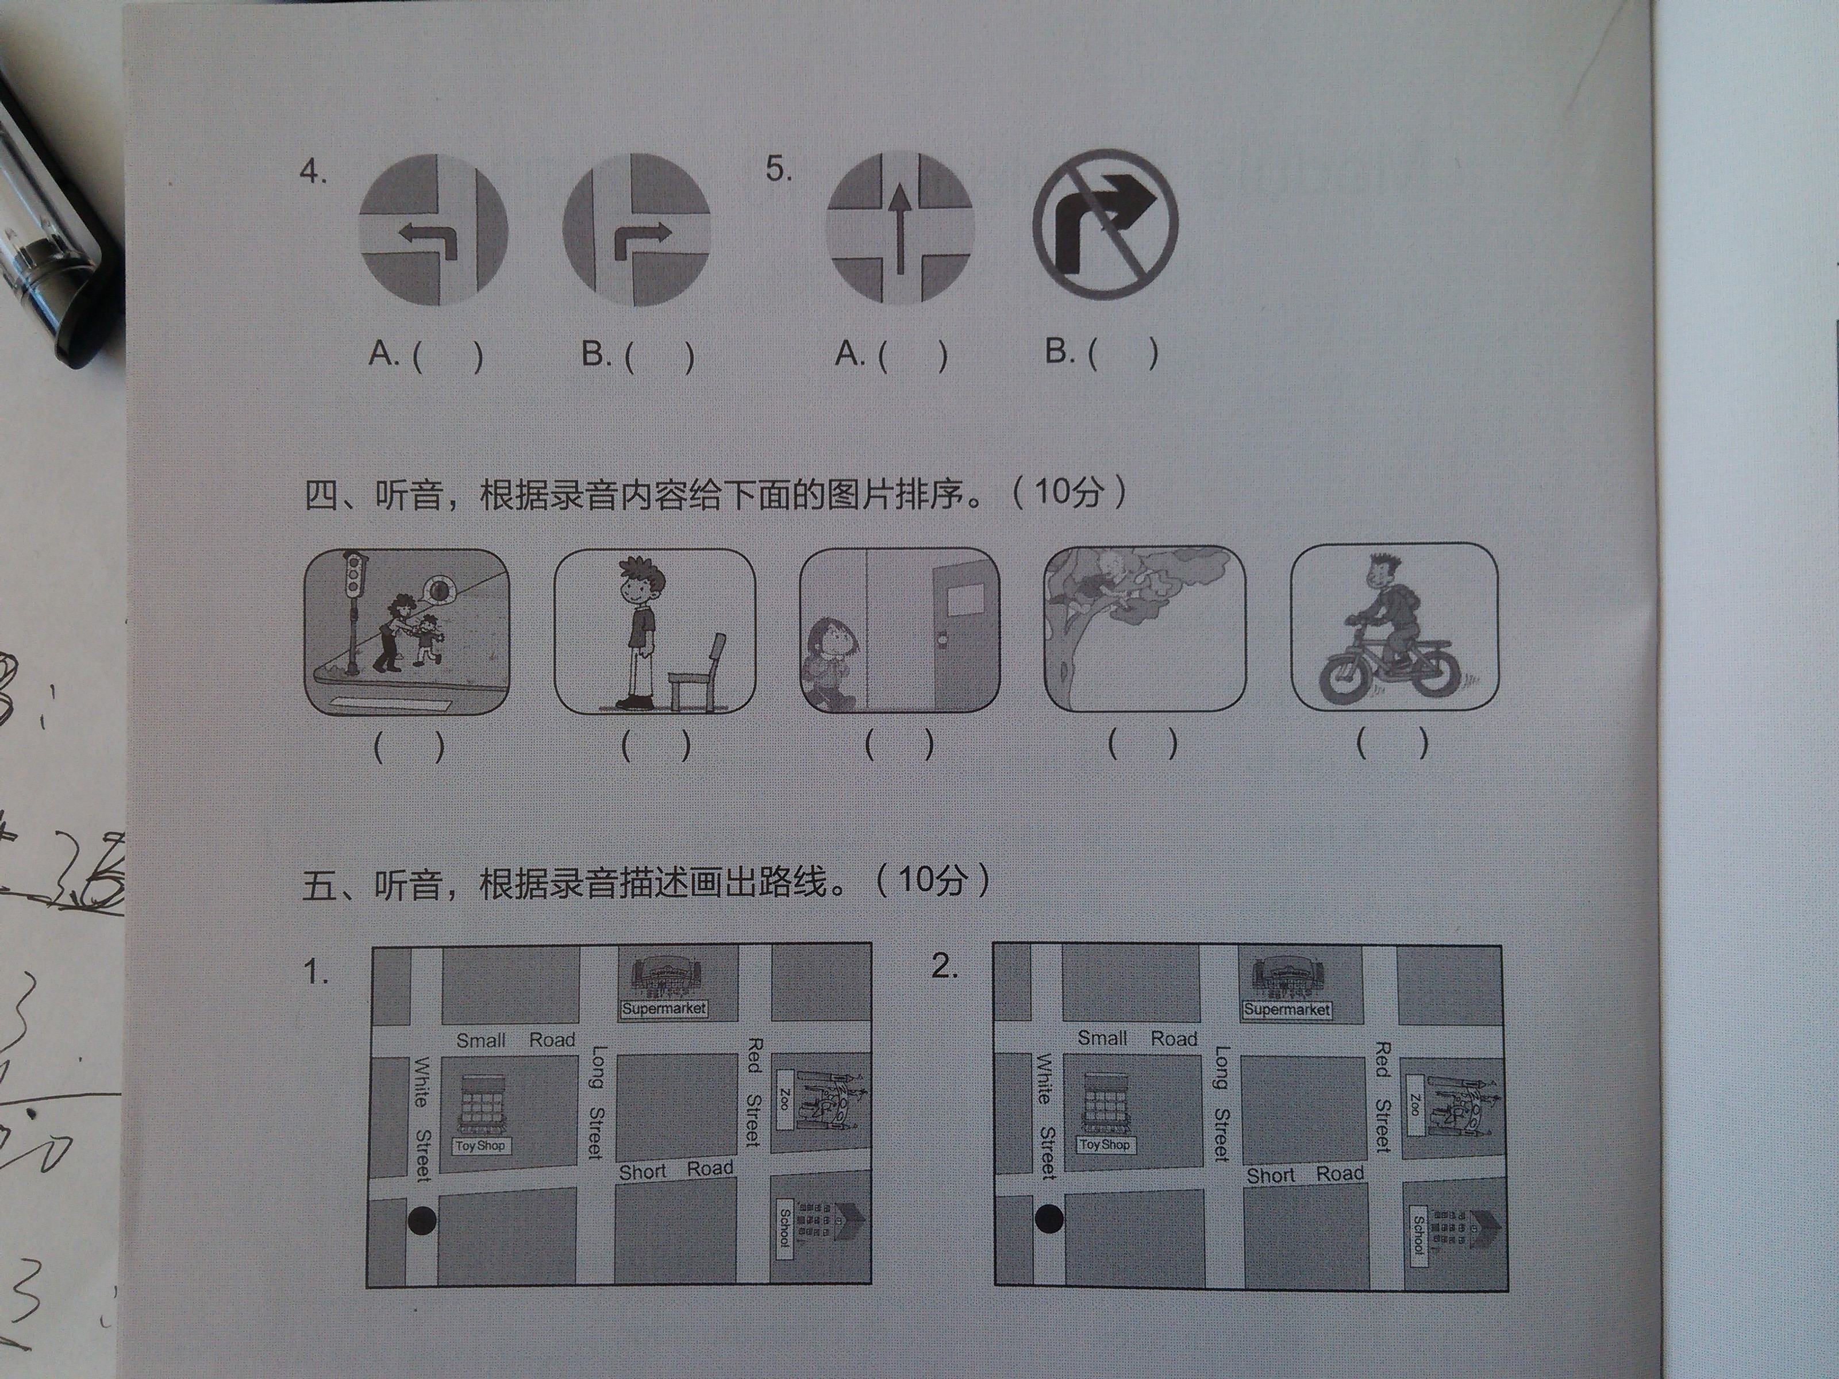
六、听音，根据录音内容给下面的图片排序。

七、听音，判断下列句子是否与短文内容相符，相符的划“√”，不相符的划“×”。新|课 |标|第 |一| 网
（ ）1.Tony is twelve years old.
（ ）2. He lives in the US.
（ ）3. He likes collecting stamps.
（ ）4.Fangfang is from China, and she can speak some English.
（ ）5. She likes singing and dancing.
基础知识题
一、找出每组单词中与其他三个不同类的一项，将编号写在括号中。
( )1. A. sing B. reading C. drawing D. playing
( )2. A. American B. Chinese C. Japanese D. Canada
( )3. A. elephant B. snake C. sheep D. winter
( )4. A. often B. clean C. always D. never
( )5. A. show B. give C. visit D. city
二、根据首字母或汉语写出单词,使句子完整, 答对4个即可。
1. Do you often c________(打扫) your room?
2. I n play football. I don’t like it.
3. Collecting dolls is my h . I like dolls.
4.The snake can use its b__________(身体) to dance.
5. Don’t talk in the library. Please be q !
三、根据汉语提示，写出短语，完成句子, 答对4个即可。
1. There are flags from the world (世界各地) .
2. Please stand _______ ________(排队).
3. It’s beautiful, I want to (照一些相).
4. Can you help me? (没问题).
5 (看) the pandas! They love bamboo.
四、将句子的序号填在对应图片的下面。
A. Don’t turn right here. B. Elephants like water.
C. Shanghai is very big and very famous.
D. I’ve got a knife and fork. w W w .x K b 1.c o M
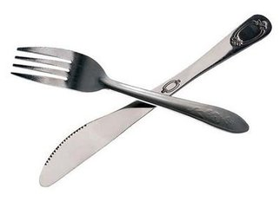
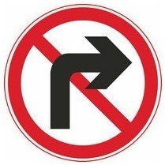
E. You’re cleaning your classroom.
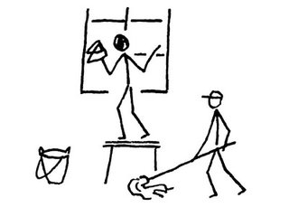

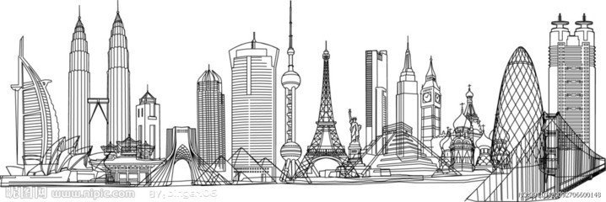
1. ( ) 2. ( ) 3. ( )
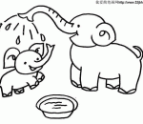

4. ( ) 5. ( )
五、单项选择，答对5个即可。
( )1. I haven’t got a football, ______ I’ve got a basketball.
A. and B. but C. too
( )2. Don’t _____late for school.
A. is B. be C. are
( )3. I want _______ the UN building.
A. visit B. visits C. to visit
( )4. Many countries give presents _______ the UN.
A. of B. for C. to
( )5. _______ like to sleep in winter.
A. Bear B. A bear C. Bears
( )6.I like ________stories at the weekends.
A. reading B. read C. reads
六、从方框中选出恰当的答语，将代号写在括号中。
A. Yes, of course. B. These are stamps from Canada.
C. Yes, I’d love to. D. No, I haven’t. E. To the park.

（ ）1.Have you got a book about China?
（ ）2.Do you want to see my photos?
（ ）3.Where are we going? 新 课 标 第 一 网
（ ）4.Can you be my Chinese pen friend?
（ ）5.What are those?
七、 连词成句，答对2个即可。w W w .X k b 1.c O m
1. don’t, I, it, believe ,(!) __________________________________
2. building, what, big, a (!)______________________________
3. five, the, closes, library, at (.)
综合能力题
八、阅读理解。
根据短文内容，选择合适的答案，将序号填在题前括号中。
A
I’m Sam. I like sports. I always play basketball in summer. And in winter I often go skating with my family. I always ride my bike to school, But sometimes I go by bus. After school, I sometimes write stories in Chinese. I like Chinese very much, but It’s very difficult for me! I never eat fast food. I don’t like it.
( )1. Sam always in summer.
A. play basketball B. play football C. goes swimming
( )2. He often goes with his family in winter.
A. swimming B. to school C. skating
( )3.He always goes to school . X k B 1 . c o m
A. by bus B. by bike C. by car
( )4. Does he like Chinese?
A. Yes, he does. B. No, he doesn’t. C. We don’t know.
B
Hello, everyone! My name is Peter. I study in Xinhua Primary School. I like reading books and doing sports. I often read books after supper. And I like reading story books and picture books. At the weekend I often go swimming with my friend. And I often play football with my friend in the park. But sometimes I stay at home and help my mum clean the room.
( )1. Peter studies in _____ Primary School.
A. Xinhua B. Yuren C. Qianjin
( )2. He likes reading story books and ______
A. Animal books. B. picture books C. Science books
( )3. Sometimes he stays at home and _______.
A. cleans the room B. watches TV C. plays football
( )4. He often plays football with his friend _______
A. in the school B. in the room C. in the park
九、写作。w W w .x K b 1.c o M
请你写一写你和你的家人在假期里想去哪里，并介绍那个地方的特点以及名胜古迹。
要求：1.语义连贯，句子通顺，表达清楚，注意信的格式和动词的正确形式。
2.要注意大小写和标点符号,句子至少10个，单词至少50个。
提示：可能用到的词汇：want to; there are; big and famous; beautiful city; north; lakes; mountains新- 课-标 -第-一 -网

系列资料 www.xkb1.com 不用注册，免费下载！

