冼沙小学三年级英语期中考核题
Name: Class: Mark
听力部分
- 听一听，圈一圈：把你听到的图片下面的字母画一圆圈圈住。（10分）
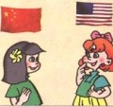
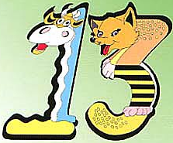
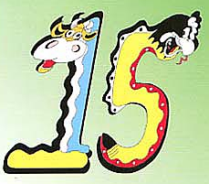
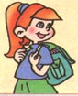
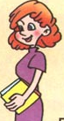
1、 2、 3、

A B A B A B
- 5、
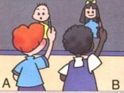
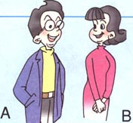

- 听一听，排一排：用阿拉伯数字为下图重新排序。（10分）
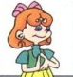
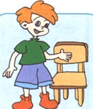
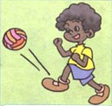
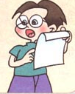
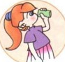

( ) ( ) ( ) ( ) ( )
三、听一听，辨一辨：判断你听到的内容是否与图片相符，相符的打√，不相符的打×。
1、 2、 3、
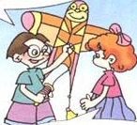
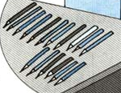
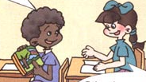

( ) ( ) ( )
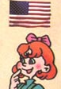
- 5、
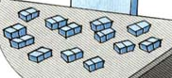

（ ） （ ）
四、听一听，填一填：。你将听到一个句子，根据你听到的内容，在表格相应的地方填写阿拉伯数字。（10分）www.xkb1.com
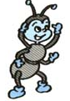 | 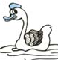 | 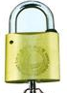 | 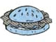 | 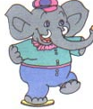
五、听一听，填一填：根据图片和听到的读音，填写单词所缺的字母。（10分）
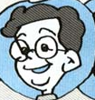
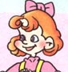
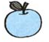
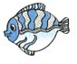


1. ather 2. irl 3. pple 4. ish 5. ce-cream

六、听一听，选一选：你将听到一个句子或一组对话，根据你所听到的内容，选择句子中念有的单词，将其编号填入括号里。（10分）
( ) 1. A. bad B. dad
( )2. A. too B. two
( )3. A. thirteen B. fourteen
( )4. A. mother B. father
( )5. A. can B. cat
( )6. A. nineteen B. eighteen
( )7. A. that B. this
( )8. A. green B. great
( )9. A. mom B. man
( )10. A. who B. what
七、听一听，涂一涂，连一连。（10分）新课标第一网
L J M F G

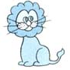
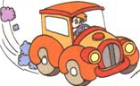


八、听一听，选一选：把你听到的合适的答句的编号填在括号里。（10分）
( )1. A: My name is Amy. B: This is Amy. C: She is Amy.
( )2. A: I am a boy. B: He is from China. C: I am from China.
( )3. A: Thank you! B: Oh, no. C: I’m fine. Thank you!
( )4. A: She is my sister. B: He is my brother. C: He is my father.
( )5. A: I have 16 kites. B: I can see 16 kites. C: I am 16.
读写部分
九、选择不同类的单词，并将其序号填在前面的括号内。（10分）
( )1 A. sister B. brother C. grandpa D. jeep
( )2 A. student B. grandma C. grandfather D. mother
( )3. A. teacher B. fourteen C. thirteen D. twelve
( )4 A. man B. woman C. goose D. girl
( )5 A. nineteen B. egg C. twenty D. elenen
十、读一读，选一选：阅读左列句子，从右列句子中找出合适的答句，并将其字母编号填在题前的知括号里。（10分）
（ ）1、Who’s this woman? A、I have 11 books.
（ ）2、How many books do you have? B、It’s OK.
（ ）3、How many kites can you see? C、Oh, no.
（ ）4、Watch out! D、He’s my mother.
（ ）5、I’m sorry. E、I can see 13.

小学三年级英语期中考核题
听力部分
一、听一听，圈一圈：把你听到的图片下面的字母画一圆圈圈住。
1. I’m from China. 2. I have thirteen apples. 3. This is my teacher. 4. She is my mother . 5.. Draw a boy.
二、听一听，排一排：用阿拉伯数字为下图重新排序。
1. ABCDE, read after me.. 2. EFG, have a seat. 3. KKK, kick, kick, kick. 4. EEE, drink some tea. 5. DDD, make a “D”
三、听一听，辨一辨：判断你听到的内容是否与图片相符，相符的打√，不相符的打×。
1. A: Look, Amy! I have a new kite. B: Oh, it’s beautiful! 新课标第一网
2. A: How many pencils do you have? B: I have 16 pencils.
3. A: Hi, Chen Jie, Look at my new crayons! B: Oh, how nice!
4. A: How many erasers can you see? B: I can see 13 erasers.
5. A: Where are you from? B: I am from Canada.
四、听一听，填一填：。你将听到一个句子，根据你听到的内容，在表格相应的地方填写阿拉伯数字。
1.A: How many ants can you see? B: I have 12 ants.
2. A: How many geese can you see.? B: I can see 13 geese.
3. A: How many locks do you have? I have 15 locks .
4. A: How many hamburgers do you have? I have 20 hamburgers.
5. A: How many elephants can you see? I can see 18 elephants.
五、听一听，填一填：根据图片和听到的读音，填写单词所缺的字母。
1.father 2.girl 3.apple 4. fish 5. ice-cream
六、听一听，选一选：你将听到一个句子或一组对话，根据你所听到的内容，选择句子中念有的单词，将其编号填入括号里。
1. He is my dad. 2. Nice to meet you, too. 3. I have thirteen apple. 4. Who’s that woman? She’s my mother. 5. How many fish can you see? 6. I can see eighteen ducks. 7. This is my father. 8. Let’s watch TV. Great! 9.Who’s this man? He’s my teacher. 10. Who’s that girl? She’s my sister.
七、听一听，涂一涂，连一连
1.Colour letter J pink, J, pink. Match it with the jeep.
2. Colour letter F blue, F, blue. Match it with the fish.
3. Colour letter M green, M, green . Match it with the mother.
4. Colour letter L red, L, red . Match it with the lion.
5. Colour letter G orange, G, orange. Match it with the Goose.
八、听一听，选一选：把你听到的合适的答句的编号填在括号里。
1.What’s your name?
2. What are you from ?
3. Happy women’s Day! Miss White!
4. Who’s that boy?
5. How many kites can you see?

