英语听力综合复习题
寮步镇上屯小学 英语科组
一、你将听到一个句子，根据听到的内容选择符合的一项。
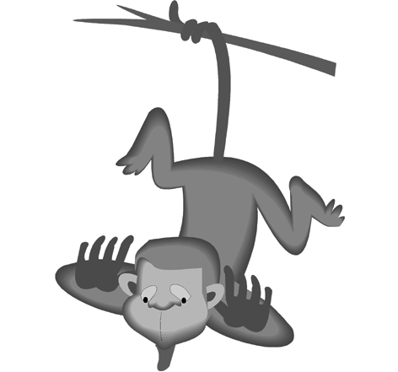
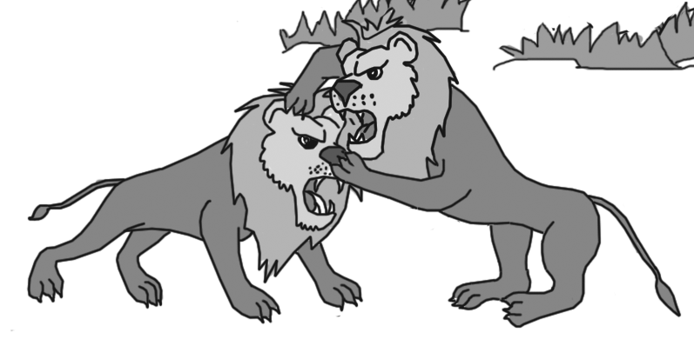
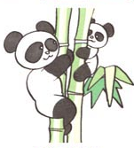
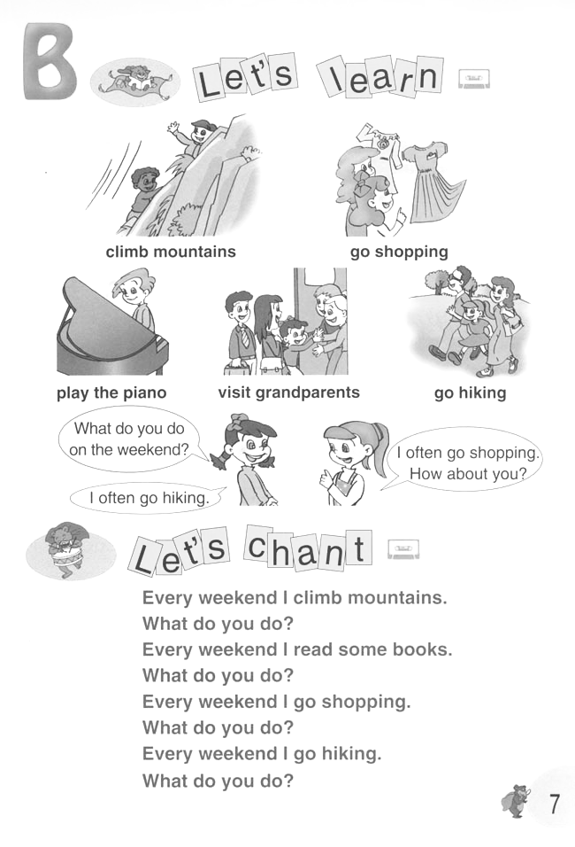

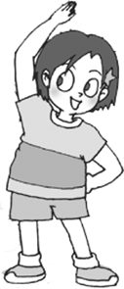
( ) 1. A. B. . C.

( ) 2. A. B. C.
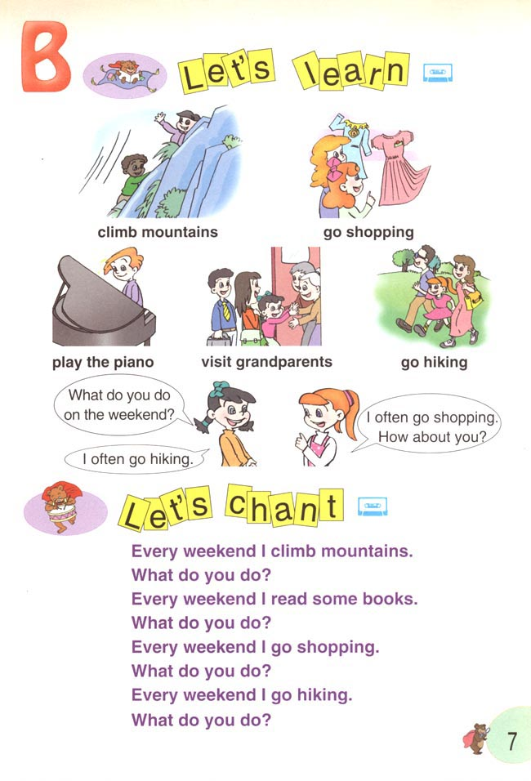
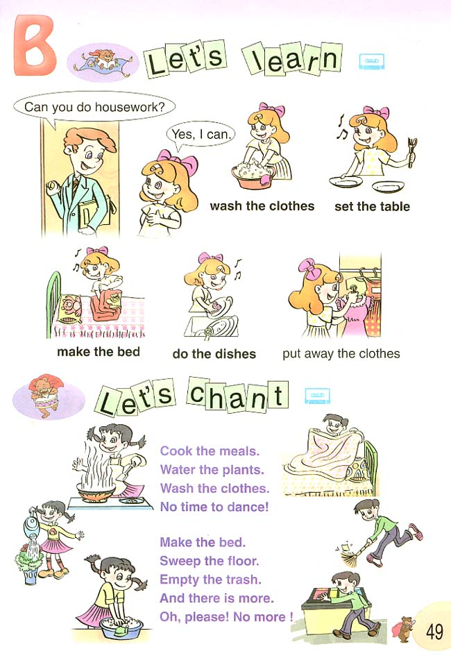
( ) 3. A.  B. C.
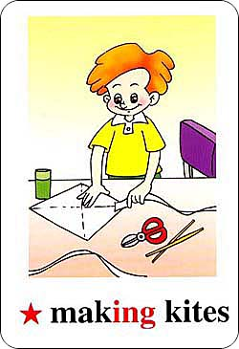
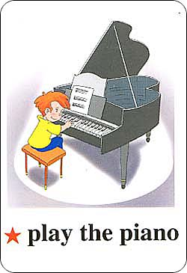
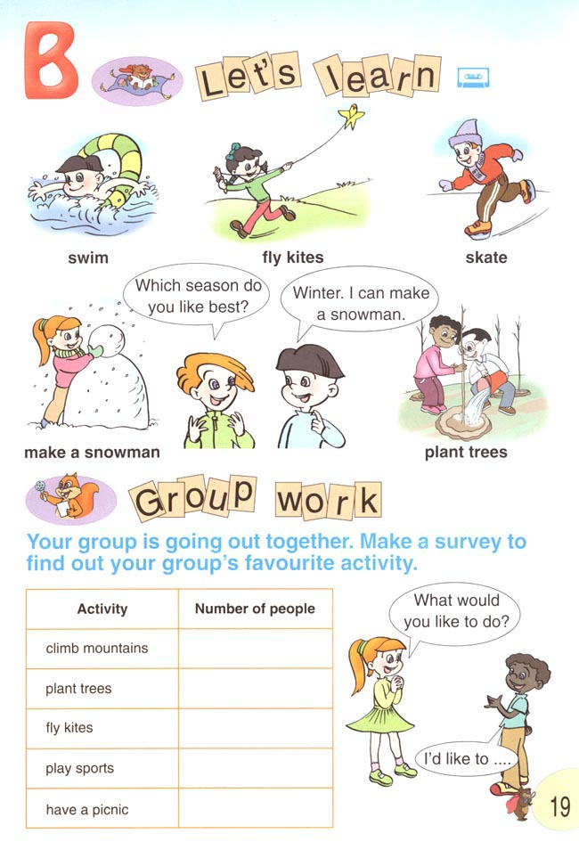
( ) 4. A. B. C.


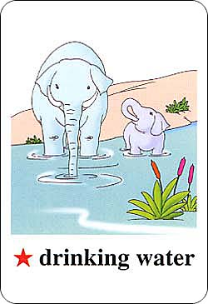
( ) 5. A. B. C.
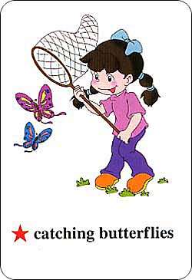
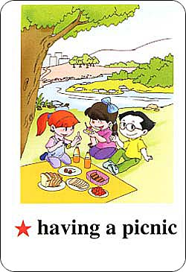
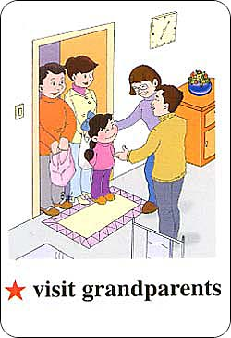
( ) 6. A. B. C.
( ) 7. A.  B.  C. 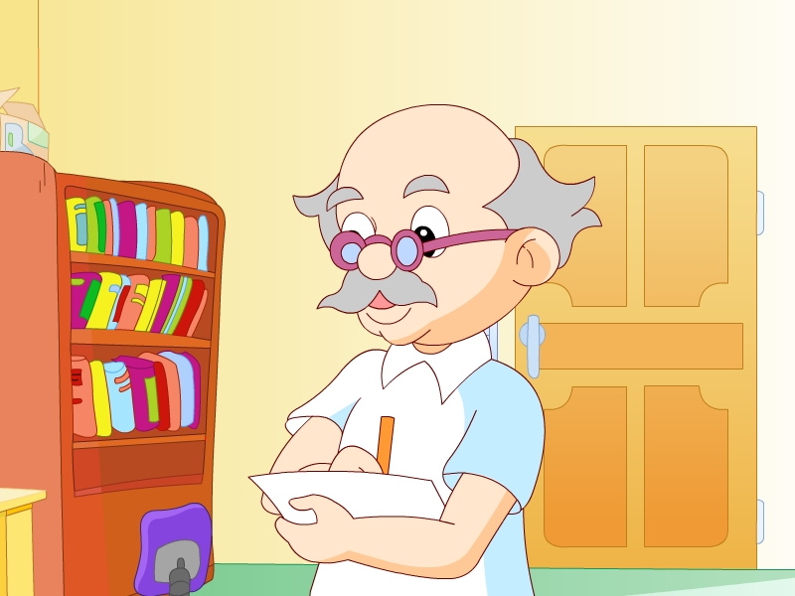
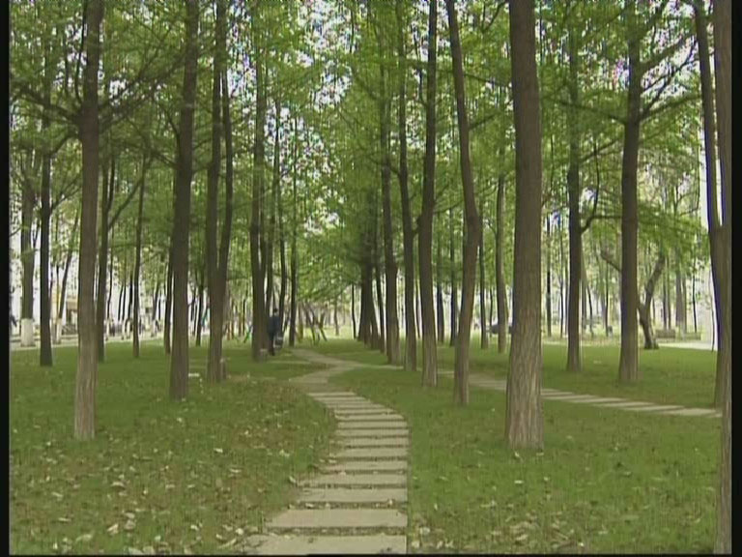
( ) 8. A. B. 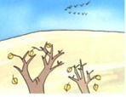 C. 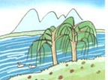
( ) 9. A. Who B. When C. Where
( ) 10. A. girl B. boy C. toy
( ) 11. A. she B. he C. they
( ) 12. A. the shirt B. the skirt C. the girl
( ) 13. A. Mr B. Mrs C. Miss
( ) 14. A. thin and short B. thin and tall C. short ant strong
( ) 15. A. China B. Canada C. USA
( ) 16. A. math class B. Chinese class C. science class
( ) 17. A. on Sunday B. on Tuesday C. on Thursday
( ) 18. A. go hiking B. go shopping C. go swimming
( ) 19. A. new students B. new teachers C. new classmates
( ) 20. A. play the piano B. play the violin C. play football
( ) 21. A. date B. today C. may
( ) 22. A. game B. make C. name
( ) 23. A. play basketball B. play games C. play computer
( ) 24. A. make a kite B. make the bed C. make a snowman
( ) 25. A. fruit B. foot C. food
( ) 26. A. what B. which C. week
( ) 27. A. rain B. windy C. spring
( ) 28. A. the weather B. the sweater C. the father
( ) 29. A. When is your father’s birthday?
B. When is your mother’s birthday?
C. When is your brother’s birthday?
( ) 30 . A. Tree-planting Day is in spring.
B. National Day is in October.
C. Today is Christmas Day.

二、你将听到一个句子或一组对话，根据所听到的内容，判断图片或句子是否与录音相符，相符的打“√”，不相符的打“×”。
1． 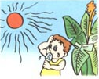 2. 3.
( ) ( ) ( )
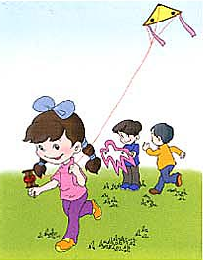
4. 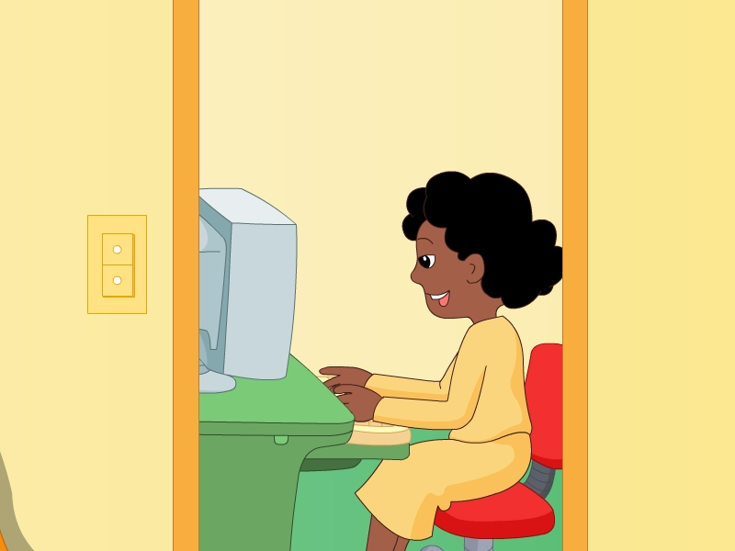 5. 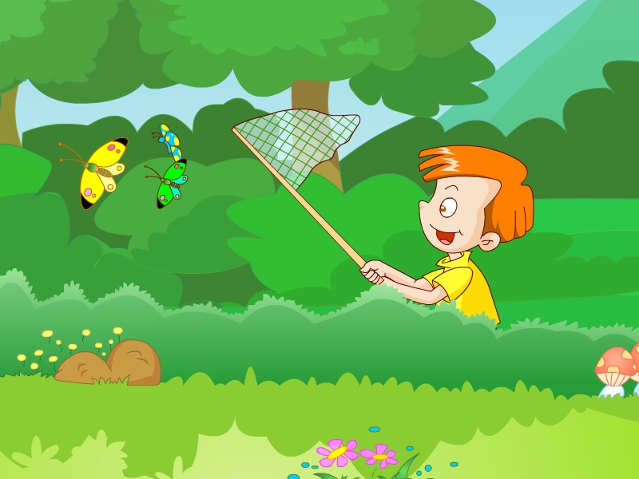 6.
( ) ( ) ( )
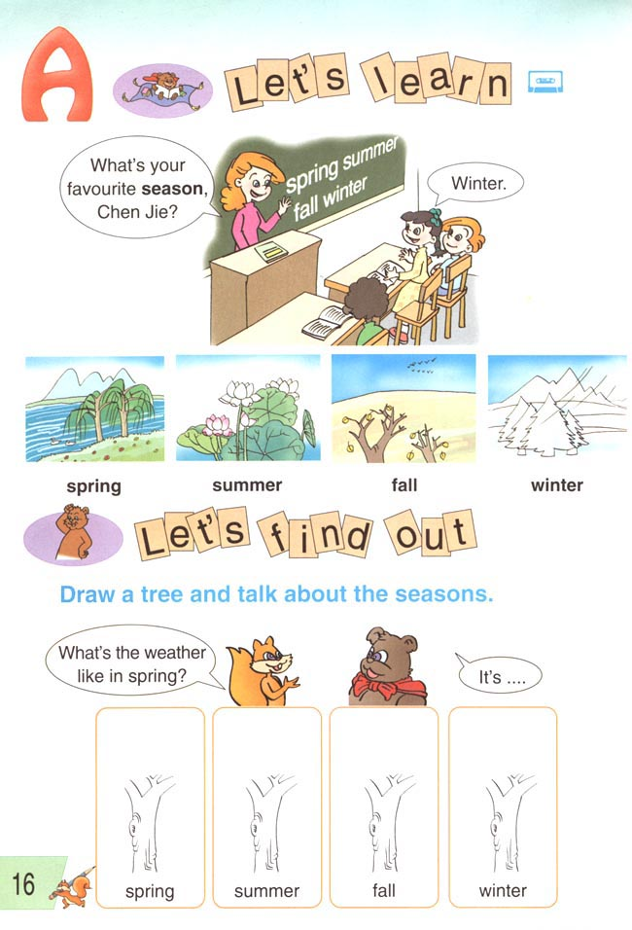
7. 8. 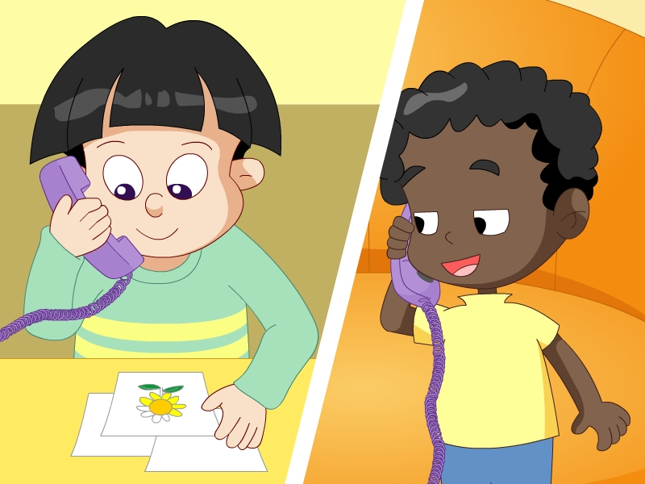 9. 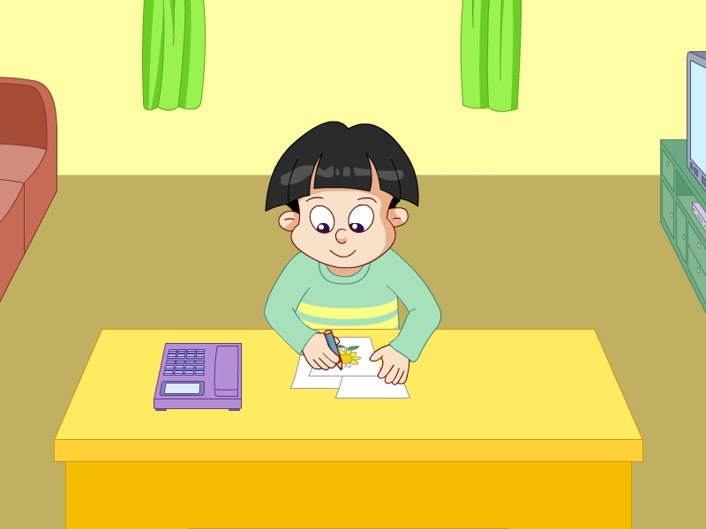
( ) ( ) ( )
10. 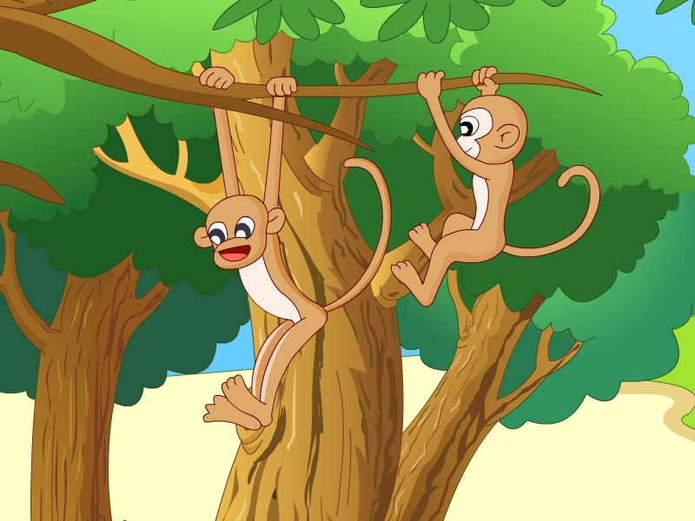 11. 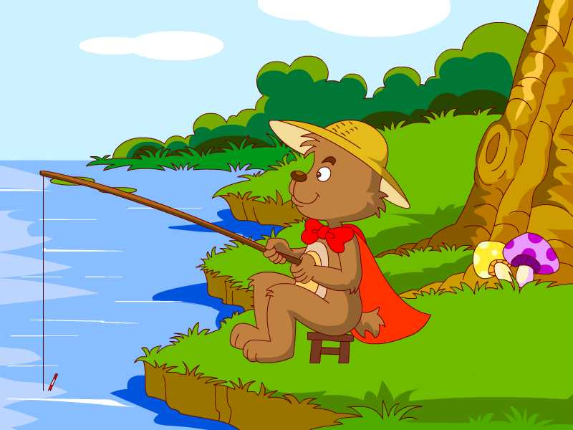 12. 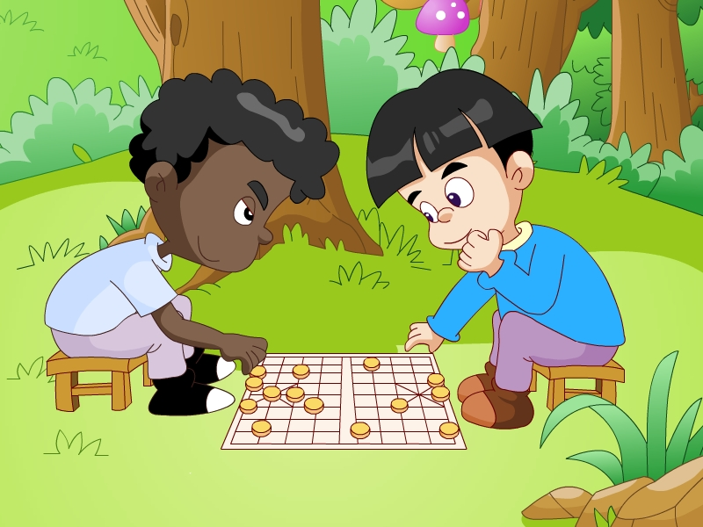
( ) ( ) ( )
13.  14. 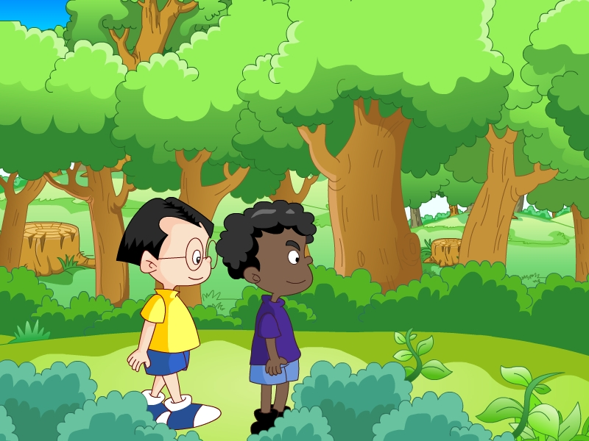 15. 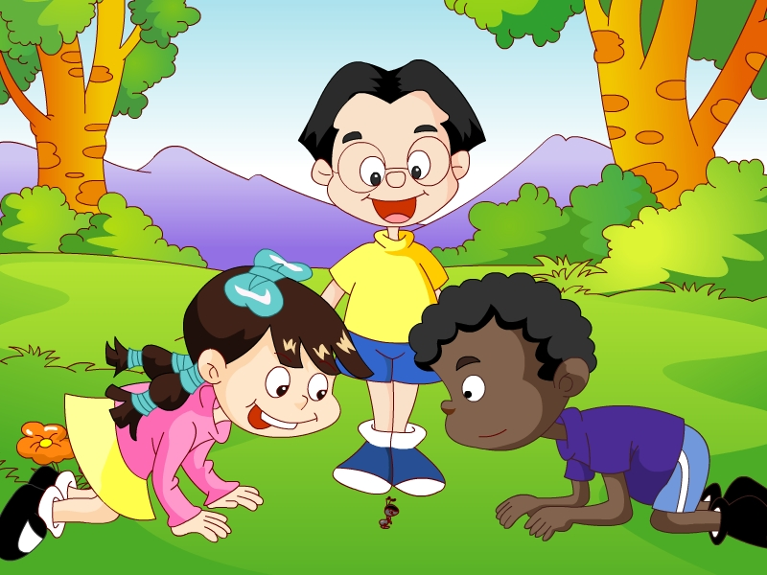
( ) ( ) ( )
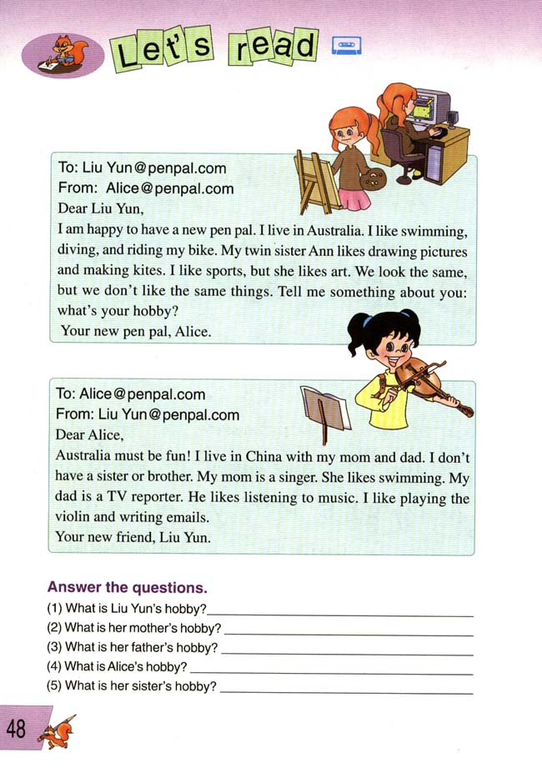
- 17. 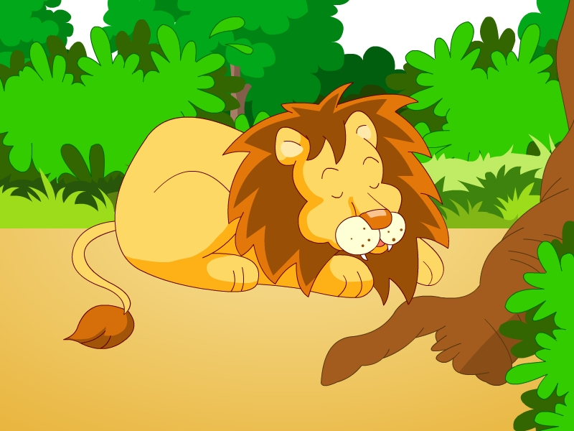 18.
( ) ( ) ( )

( ) 19. I usually get up at 6:30.
( ) 20. I don’t like spring. I like winter best.
( ) 21. Summer is hot and the days are long.
( ) 22. Mom is cooking dinner in the kitchen.
( ) 23. He’s reading a book.
( ) 24. I’m answering the phone.
( ) 25. It’s Teachers’ day.
( ) 26. There are two birthdays in June.
( ) 27. She is collecting leaves.
( ) 28. They are playing together.
( ) 29. He doesn’t like winter.
( ) 30. We have a big dinner and eat a birthday cake.
( ) 31. My birthday is March 12th.
( ) 32. Wu Yifan is writing a report.
( ) 33. Mike likes fall best.
( ) 34. It is June 1st today
( ) 35. I play computer games on the weekend
( ) 36. I am making a birthday cake
( ) 37. we are doing an experiment on insects
( ) 38. We usually do some sports on the weekend
( ) 39. She likes tigers best
( ) 40. I’m washing the clothes
三.听录音，根据听到的问题，选择最合适的答句，将其前面的字母编号填在题号前的括号内。
( ) 1. A. They are monkeys. B. I am Mike.
C. They are my teachers.
( ) 2. A. Yes, I can. B. Sure. C .Yes, I am.
( ) 3. A. He is young. B. He like cabbage. C. Yes, he is.
( ) 4. A. I often read books and go shopping on the weekend.
B. I often do homework every afternoon.
C. I’m going to take a trip this week.
( ) 5. A. Yes, he is. B. Yes, they are. C. Yes, I am.
( ) 6. A. Yes, I can swim. B. Yes, I can fly a kite.
C. Yes, I like.
( ) 7. A. Yes, it’s pretty. B. Yes, I am. C. Yes, it does.
( ) 8. A. Mike is cleaning the room.
B. John is writing a letter.
C. Amy is listening to music.
( ) 9. A. He swam. B. He is swimming.
C. He is going to swim.
( ) 10. A. It’s May 1st. B. It’s Monday. C. Today is May 1st.
( ) 11. A. Yes, I’m a policeman. B. No, he isn’t. C. Yes, it is.
( ) 12. A. Usually I play the piano.
B. I often do morning exercises in the morning.
C. I can play the piano.
( ) 13. A. I’m from America. B. I’m reading books.
C. I’m a teacher.
( ) 14. A. I often go to work at 5:00. B. I often go home at 5:00.
C. I often have dinner at 5:00.
( ) 15. A. I go shopping every weekend.
B. I go hiking every morning.
C. He plays football every weekend.
( ) 16. A. Yes, I can. B. No, I don’t. C. Yes, I am .
( ) 17. A. They are students. B. They are yellow.
C. They are hungry.
( ) 18. A. Because it is too cold.
B. Because it is too hot.
C. Because it is too windy.
( ) 19. A. She likes fall best.
B. He likes playing football best.
C. I like spring best.
( ) 20. A. I often have a picnic in a park.
B. I would like to climb mountains.
C. I can make a snowman.
( ) 21. A. Yes, he is. B. Yes, he does. C. Yes, it is.
( ) 22. A. My birthday is in February.
B. His birthday is in December. C. Her birthday is in July.
( ) 23. A. I. B. She. C. Me.
( ) 24. A. I often get a birthday card. B. I’m playing football.
C. He is buying a present in the shop.
( ) 25. A. It’s in the morning. B. It is in March. C. Here it is.
( ) 26. A. Yes, it does. B. No, it is not. C. No, it doesn’t.
( ) 27. A. It is Monday. B. It is July 3rd. C. It is windy.
( ) 28. A. John’s birthday is in July.
B. Sarah’s birthday is in June.
C. Jack’s birthday is in August.
( ) 29. A. In the morning. B. In the sky. C. In the garden.
( ) 30. A. He has a teacher. B. He is a teacher.
C. He plays football.
( ) 31. A. Her birthday is in June. B. His birthday is in June.
C. She is in June.
( ) 32. A. I’m going to swim. B. I’m reading a book.
C. I’m happy.
( ) 33. A. She is nice. B. He is a policeman.
C. She is in the school.
( ) 34. A. I like China best. B. I like skirts best.
C. I like math class best.
( ) 35. A. Sure. B. No, she can’t. C. Yes, you can.
( ) 36. A. I’m a student. B. I’m having lunch.
C. I’m very happy.
( ) 37. A. We have math class. B. We do homework every day.
C. They listen to music.
( ) 38. A. Yes, you can. B. Please hold on. C. No, you can’t.
( ) 39. A. We are cleaning our classroom.
B. They are doing homework.
C. We play football.
( ) 40. A. No, there isn’t. B. Yes, there are. C. I don’t know.
( ) 41. A. Thank you. B. Goodbye. C. OK.
( ) 42. A. I see a big elephant. B. I’m looking at the elephant.
C. Yes, I see it.
( ) 43. A. They are swimming. B. We are sleeping.
C. They are in the nature park.
( ) 44. A. In the water. B. In the sky. C. In the forest.
( ) 45. A. Yes, we do. B. Yes, they do. C. No, they aren’t.
( ) 46. A. The monkeys. B. The elephants. C. The birds.
( ) 47. A. Thank you. B. You’re welcome. C. See you.
( ) 48. A. They are eating carrots. B. We are eating meat.
C. They are eating insects.
( ) 49. A. It is Monday. B. It is spring. C. It is July 5th.
( ) 50. A. I often go hiking. B. I am a teacher.
C. I want to be a teacher.

四. 听句子或对话,根据其内容填入所缺的单词，使对话或句子的意思合理、完整，每空只填一词。
1. A: When do you _____ the _______in the afternoon? B: At 4:50.
2. A: What do you do on the ________?
B: I usually ______ ______. What about you?
A: I usually ______ ______ at home. But I ______ my ________ this weekend.
3. We ____ ________ ________at school every day.
4. Let’s ____ ________ together next Saturday.
5. A: Can you ______ ______? B: Yes, I can.
6. It’s ______. It’s time to ______ ______.
7. Snakes ______ in ______.
8. A: Why do you like ________?
B: Because I can ______in the sea.
9. A: Do you like ______ a ____________? B: Yes, I do.
10. A: What’s the ______? B: It’s ______ 30th.
11. A: Who has a birthday in ____________? B: Amy.
12. ______is from ______ to ____________ in China.
13. A: What do you do on Sunday? B: I _______ ___________.
14. A: Is she ______ _______? B: No, she isn’t.
15. A: What is Jack ______ in the woods?
B: He is ______a ______.
16. I see mother _______. It’s ________.
17. I love all the ______. ________ all beautiful.
18. A: Is her birthday in ________? B: No. It’s in ________.
19. A: What’s the weather like in ______in Beijing?
B: It’s ______ and ______.
20. A: What is your father doing?
B: He is ______ a book in the ______.
21. A: Is ______ a river near the house? B: No, ______ ______.
22. A: ______you very much. B: ______ all right.
23. A: Where are your ____________?
B: They’re in the ______. They are ______ ______.
24. A: Do ______ like sweet ______?
B: Yes, they do.
25. A: ______ is Lily doing? B: She is _________ bananas.
26. A: What can you see at the ______?
B: I can see a giraffe. It’s ______ ______.
27. Tom and Mike are ______ bees. They are eating the ______.
28. A: What are the ______ doing?
B: They are ______ in the tree.
29. A: Is your father ______a______?
B: No, he is ________ to ______.
30. A: When do you do your_________?
B: _________ I do it at seven in the evening. _________ I do it at 8.
五. 听读短文，判断下列各句的正误,，对的打“√”，错的打“×”。
1
( ) 1. Tom and Mike can see many animals in the park.
( ) 2. The pandas can walk, eat bamboos and climb trees.
( ) 3. The animals are so cute.
( ) 4. Two pandas are climbing the big tree now
( ) 5. There are many animals in the zoo.
2
( ) 1. The elephants are drinking water in the park.
( ) 2. The animals are not happy in the nature park.
( ) 3. The monkeys are swinging in the tree.
( ) 4. Some tigers are sleeping under the trees.
( ) 5. Some kangaroos are under the trees.
3
( ) 1. I have a sister and a brother.
( ) 2. My father’s birthday is on June 12^{th.}
( ) 3. My little brother’s birthday is in spring.
( ) 4. Amy is making a birthday chart for her family.
( ) 5. lily’s birthday is in November.
4
( ) 1. Mike’s Grandma is cleaning the room.
( ) 2. Mike is busy answering the phone.
( ) 3. Mike’s mother is cooking now.
( ) 4. Mike’s father is reading a newspaper.
( ) 5. Mike’s sister is doing housework.
5
( ) 1. John is in Grade Five.
( ) 2. John gets up at 6:20
( ) 3. John likes English class and math class.
( ) 4. John does some morning exercises at 7:30.
( ) 5. John is a good student.
6
( ) 1. It’s cool and windy today.
( ) 2. Tom and Mike are listening to music
( ) 3. Amy is cooking dinner with Chen Jie.
( ) 4. They are very happy.
( ) 5. They are having a picnic in the forest.
7
( ) 1. The animals are very cute.
( ) 2. The big monkey is swinging in the tree.
( ) 3. There are three monkeys in the zoo.
( ) 4. You can see some tigers. They are sleeping
( ) 5. The big elephant is drinking water.
8
( ) 1. It’s not a fine day.
( ) 2. Sue and Lucy are picking up leaves.
( ) 3. Harry is catching butterflies with Jack.
( ) 4. They are in the nature park.
( ) 5. The teachers are doing an experiment.
9
( ) 1. Miss Li is a Chinese Teacher.
( ) 2.You can see a picture of a cat.
( ) 3. The dog is black and white.
( ) 4. The dog is running to us.
( ) 5. The students have an English class on Tuesday.
10
( ) 1. Mike is cleaning the room now.
( ) 2. Sarah is watering the flower.
( ) 3. John is washing clothes.
( ) 4. Chen Jie is answering the phone
( ) 5. The teacher is doing housework.
参考答案：
一：BBAAA BCBBB ABABA CCAAA BBACA BCACA
二：√×√×× √×××√ √√√×× √×√×√
×××√√ ×√√×√ √×√√× ××√×√
三：CBAAC CACBA BABBA BABCA BCCCB ABBCB
ABCCA ACBAB AACAC CBAAC
四：
1. A: play
2. A: weekend
B: go hiking
A: play chess visit grandparents
3. do morning exercises 4. go shopping
5. A: fly kites
6. spring plant trees.
7. sleep winter.
8 summer swim
9. A: making snowman?
10. A: date B: May
11. A: December?
12. Fall August October
13. B: climb mountains.
14. A: counting insects?
15. A: doing
B: writing report.
16. elephant walking.
17. seasons. They are
18. A: November B: September.
19. A: fall
B: sunny cool.
20. B: reading study
21. A: there B: there isn’t.
22. A: Thank B: That’s
23. A: classmates?
B: woods catching butterflies.
24. A: ants food?
25. A: What counting
26. A: zoo?
B: drinking water.
27. watching honey.
28. A: moneys
B: swinging
29. A: writing letter
B: listening music.
30. A: When homework?
B: Usually Sometimes
五：
1、×√√√√ 2、××√×√ 3、√√×√× 4、√√√×√
5、√×××√ 6、√×√√× 7、√××√× 8、×××√√
9、××√×√ 10、√××√×

听力材料
一、你将听到一个句子，根据听到的内容选择符合的一项。
1. They are fighting.
2. I go shopping on the weekend.
3. I like drawing pictures.
4. I can play the piano.
5. What are they doing? They are drinking water.
6. What is Chen Jie doing now? She is having a picnic.
7. What’s your grandpa doing? He’s writing.
- Where are the birds? They’re in the sky.
- When do you go to school?
- The boy gets up at 6:30.
- This is my sister. She goes home at 5:00 every day.
- I like the skirt. It’ s pretty.
- Mr. Zhong is my PE teacher. He is smart.
- My English teacher is young. She is thin and tall.
- I am a Chinese girl. I am from China.
- We have science class on Wednesday.
- On Thursday I have P.E. class.
- I go hiking on Sunday.
- There are five new students in the classroom.
- Usually I play the piano on the weekend.
- What day is it today? It’s Monday.
- I can make kites.
- I am going to play basketball on Sunday.
- I like winter best, because I can make a snowman.
- What’s your favorite fruit?
- Which season do you like best?
- I don’t like spring, I like winter.
- What’s the weather like in Beijing?
- When is your brother’s birthday?
- Tree-planting Day is in spring
二、你将听到一个句子或一组对话，根据所听到的内容，判断图片或句子是否与录音相符，相符的打“√”，不相符的打“×”。
- In summer. It’s very hot.
- What are they doing? They’re climbing trees.
- Amy is helpful. She can make the bed.
- What is your mother doing? She is writing a letter.
- Is Mike watching insects? Yes, he is .
- Why does Chen Jie like spring?
Because she can fly kites.
- Which season do you like best? I like fall best.
- What is John doing? He is drawing pictures.
- Is Zhangpeng doing housework? No, he isn’t.
- Look at the monkeys. They are swinging.
- Zoom is go fishing near the river.
- What are they doing? They are playing chess.
- The tigers can’t swim.
- Are they climbing mountains? Yes, they are.
- They are catching butterflies. They are happy.
- In winter. It’s windy and cold.
- Is the tiger sleeping? Yes, it is.
- She is usually drawing pictures on the weekend.
19. When do you get up? Usually I get up at 6:20.
20. Which season do you like best?
I like winter best.
21. Is summer hot ? Yes, it is.
22. What is your aunt doing? She is cooking dinner in the kitchen.
23. What is Amy doing? She’s reading a book.
24. What are you doing? I’m answering the phone.
25. What’s the date? It’s Oct. 9th.
26. My birthday is in June. My brother’s birthday is in July.
27. Is Sarah collecting stamps? No, she is collecting leaves.
28. Mike is playing football. John is playing football, too.
29. I am Lily. I don’t like winter. It’s too cold.
30. I have a big dinner and eat a birthday cake with my friends.
31. Today is Tree -Planting Day. It’s my birthday.
32. Where is Wu Yifan? He is in the study. He is writing a letter.
33. What’s your favourite season? I like fall.
34. Are you happy? Yes, today is Children’s Day.
35. I play computer game on Sunday.
36. Today is my birthday.
My mother is making a birthday for me.
37. What are you doing there?
I am doing an experiment?
What experiment?
What do the ants like to eat?
38. We play ping-pong on Saturday morning.
We play football on Sunday afternoon.
39. Which animal do you like best? I like my pet dog best.
What about you, John?
I like tigers best.
40. A: Hello, This is Mike.
B: Hello, Mike. This is Chenjie.
A: What are you doing?
B: I am washing the clothes with my mother.
三.听录音，根据听到的问题，选择最合适的答句，将其前面的字母编号填在题号前的括号内。
1. Who are they?
- May I have a look?
- What’s our principal like?
- What do you often do on weekends?
- Are you helpful at home?
- Do you like summer?
- Do you like this park?
- What is the girl doing?
- What’s Liu Tao doing?
- When is your birthday?
- Is he a policeman?
- What do you often do?
- What are you doing?
- When do you go home?
- What do you do every weekend?
- Do you like winter?
- Who are they?
- You don’t like summer. Why?
- Which season do you like best?
- What can you do in winter?
- Does Mike like spring?
- When is your mother’s birthday?
- Who is doing homework now?
- What is Jack doing?
- When is Tree-planting Day?
- Does the panda like eating bamboo?
- What’s the date?
- Whose birthday is in June?
- Where are the ducks?
- What does he do?
- When is your aunt’s birthday?
- What are you doing?
- Where is Sarah?
- What’s your favorite class?
- Can I speak to you father, please?
- What do you do?
- What do they do every day?
- Can I speak to Tom?
- What are you doing now?
- Are there four seasons in a year?
- Come and have a look at the ants.
- What do you see?
- Where are the students?
- Where is the fish?
- Are they picking up leaves?
- Who can swing?
- I can take pictures. Thank you.
- What are the rabbits eating?
- What day is it today?
- What do you want to be?
四. 听句子或对话,根据其内容填入所缺的单词，使对话或句子的意思合理、完整，每空只填一词。
1. A: When do you play the piano in the afternoon? B: At 4:50.
2. A: What do you do on the weekend?
B: I usually go hiking. What about you?
A: I usually play chess at home. But I visit my grandparents this weekend.
3. We do morning exercises at school every day.
4. Let’s go shopping together next Saturday.
5. A: Can you fly kites? B: Yes, I can.
6. It’s spring. It’s time to plant trees.
7. Snakes sleep in winter.
8 Why do you like summer? Because I can swim in the sea.
9. A: Do you like making a snowman? B: Yes, I do.
10. A: What’s the date? B: It’s May 30th.
11. A: Who has a birthday in December? B: Amy.
12. Fall is from August to October in China.
13. A: What do you do on Sunday? B: I climb mountains.
14. A: Is she counting insects? B: No, she isn’t.
15. A: What is Jack doing in the woods?
B: He is writing a report.
16. I see mother elephant. It’s walking.
17. I love all the seasons. They are all beautiful.
18. A: Is her birthday in November? B: No. It’s in September.
19. A: What’s the weather like in fall in Beijing?
B: It’s sunny and cool.
20. A: What is your father doing? B: He is reading a book in the study.
21. A: Is there a river near the house? B: No, there isn’t.
22. A: Thank you very much. B: That’s all right.
23. A: Where are your classmates?
B: They’re in the woods. They are catching butterflies.
24. A: Do ants like sweet food?
B: Yes, they do.
25. A: What is Lily doing? B: She is counting bananas.
26. A: What can you see at the zoo?
B: I can see a giraffe. It’s drinking water.
27. Tom and Mike are watching bees. They are eating the honey.
28. A: What are the moneys doing?
B: They are swinging in the tree.
29. A: Is your father writing a letter?
B: No, he is listening to music.
30. A: When do you do your homework?
B: Usually I do it at seven in the evening. Sometimes I do it at 8.
五. 听读短文，判断下列各句的正误,，对的打“√”，错的打“×”。
1
Tom and Mike are at the zoo. They are very happy. They can see many animals. Now they’re talking.
Tom: Look, Mike. I can see some pandas.
Mike: Oh, Yeah. They’re so cute. Let’s go and have a look.
Tom: They can walk, eat bamboos and climb trees.
Mike: What? Climb trees?
Tom: Yes. Look, the two pandas are climbing the big tree now.

2 In the nature park. The animals are very happy and active. They are doing many things. The elephants are drinking water in the river. The monkeys are swinging in the tree. Some kangaroos are sleeping under the trees. Some tigers are walking in the woods.

3 I ‘m Amy. I am making a birthday chart for my family. There are 6 people in my family. My father’s birthday is on Jan.12th. My grandma’s birthday is on Mar.10th. I have a brother and a sister. My little brother’s birthday is on May 9th. My big sister’s birthday is on Aug. 20th. My mother and my birthday are in winter. My mother’s birthday is on October 2nd. Mine is on Nov. 21st.

4 Hello. This is Mike. We are very busy now. Grandparents are cleaning the room. Mom is cooking dinner. Dad is sweeping the floor. My sister is setting the table. What about me? I’m busy answering your phone.

5 Hello. My name is John. I am in Grade Five. I am a good student. I get up at six thirty in the morning. I go to school at seven. I have breakfast at seven ten. I do some morning reading at seven thirty. I do morning exercises at eight. I have six classes every day. I like English and Chinese. I go home at five.

6 Today is Sunday. It’s cool and windy. The students are having a picnic. They’re in the park. Zhang Peng is taking pictures for his classmates. Amy and Chen Jie are cooking dinner. John and Mike are listening to music. Miss Zeng and Tom are picking up leaves. They are having a good time.

7 Look at the animals. The monkey is eating the peaches. The baby monkey is swinging in the tree. The lion is running. The big elephant is playing water. The tigers are sleeping. They are so cute.

8 It’s a sunny day. We are playing in the nature park. I am drawing pictures with Tom. Sue is taking pictures. Jack and Lucy are picking up leaves. Harry is catching butterflies. The girls are watching insects. What are the teachers doing? They’re doing an experiment.

9 Today is Tuesday. The students of Class Two, Grade Five. They are having English class. Look, that’s their teacher, Miss Li. She is speaking English to them. She is talking about the pictures. It’s a picture of a dog. In the picture, the dog is running. It’s black and white. It’s very cute.

10
Teacher: Now, Everybody. Do an action. What are you doing, Sarah?
Sarah: I’m cooking dinner.
Teacher: What are you doing, Mike?
Mike: I’m cleaning the room.
Teacher: What are you doing, Amy?
Amy: I’m washing clothes.
Teacher: What are you doing, John?
John: I’m watering the flower.
Teacher: What are you doing, Chen Jie?
Chen Jie: I’m answering the phone.

